

Award Form
What is in this book

Page 3........ Hard words

Page 7........ Who will you nominate?

Page 9....... Details

Page 23........ Let us ask you

Page 27........ I agree


Hard words

This book has some hard words.

The first time we write a hard word
- the word is in blue.

- we write what the hard word means.


You can get help with this book

You can get some one to help you
● read this book
● know what this book is about
● find more information.

About this book


This book is the form for the award.

This is a form to nominate.

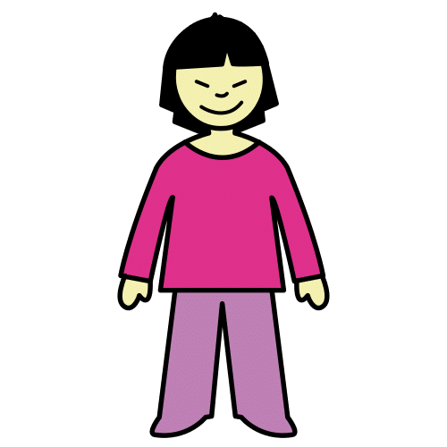
You think some one should win.
You pick them. They may win.



You can pick
- You
- Some one else.

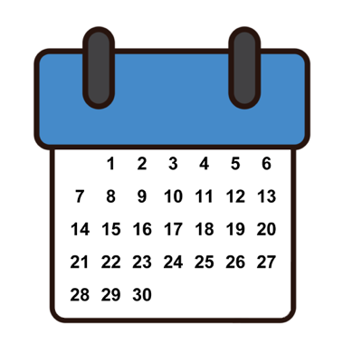
It will close on 30 October 2026.
This is the last day.


Read the guide first.


Ask for help to do this form.

Who will you pick?

Put an X in the right box.

Me

Some one else.


Name of the person you will pick

Type here

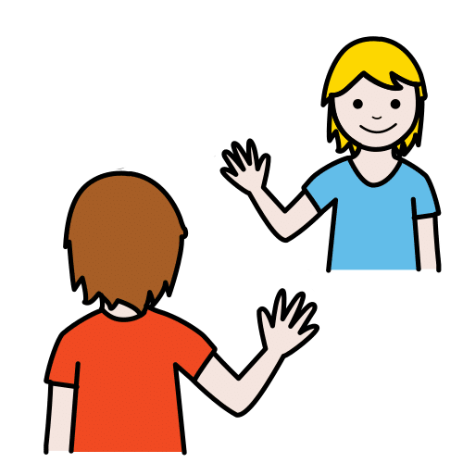
How do you know the person?

Type here


Your email

Type here

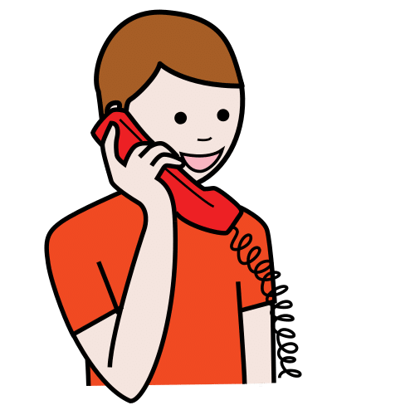
Your phone

Type here
Their Details

Name

Type here

The artist may have a stage name

Type the here

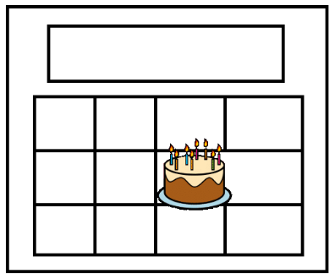
Their birthday

Type here


Their pronouns.
This can be
- She her
- He him
- They them.

Type here


Their gender.
Put an X in the right box.


Female


Male


Non binary


I do not want to say

Are they First Nations?
Put an X in the right box.


Aboriginal

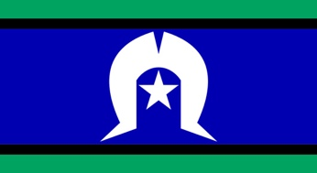
Torres Strait Islander


No

I do not want to say

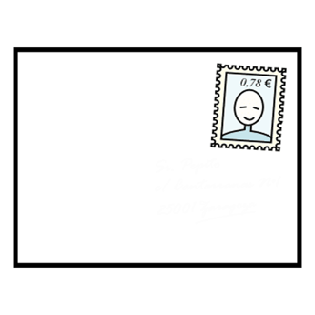
Their post code

Type here

Their email

Type here


Their phone number

Type here

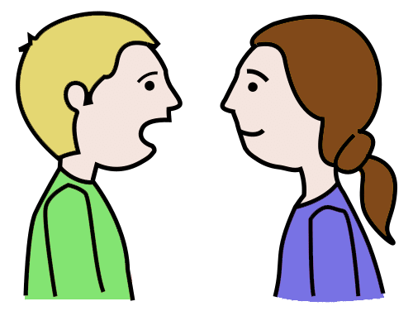
How can we talk to them?
Put an X in the right box.

Email


Phone call

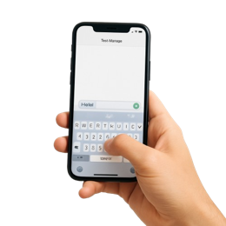
Text

Some one else
Type here


Website

Type here



Instagram

Type here


Facebook

Type here

We can not talk to you.
Give a different way.

Other person name

Type here

Other phone number

Type here

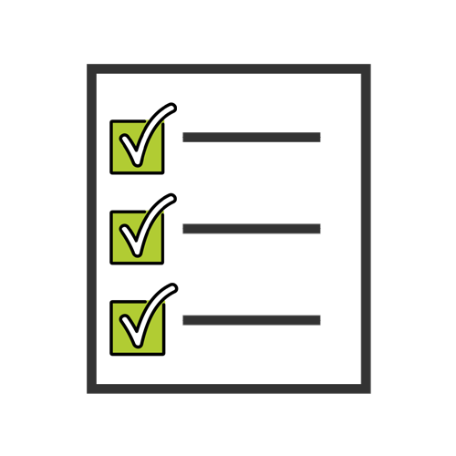
Can you apply?

Do they
- Make art

- Help people make art ?

Put an X in the right box.


Yes


No

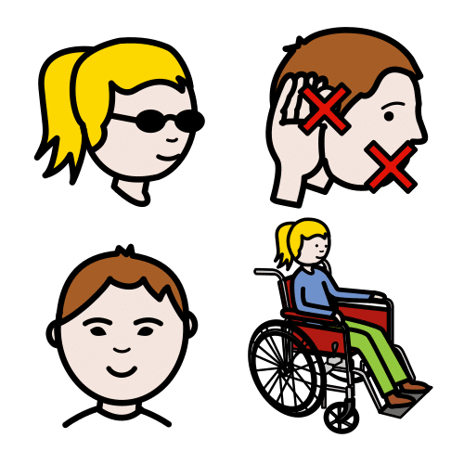
Are they a
- Person with a disability
- Deaf ?



Do people know?

Put an X in the right box.

Yes

No

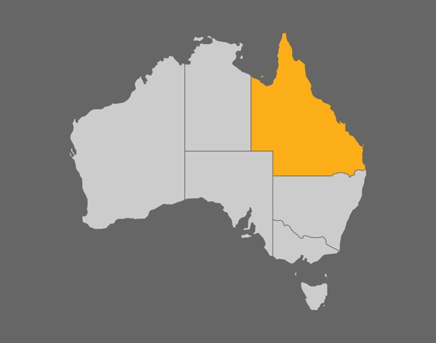
Do they live in Queensland?
Put an X in the right box.

Yes


No

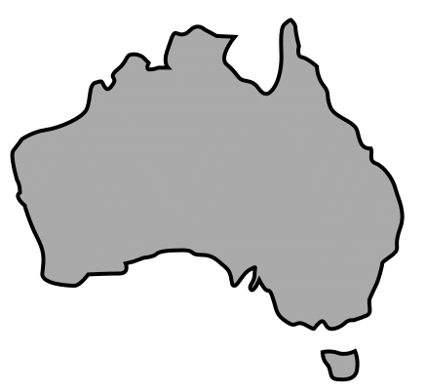
Are they Australian?
Put an X in the right box.

Yes

No

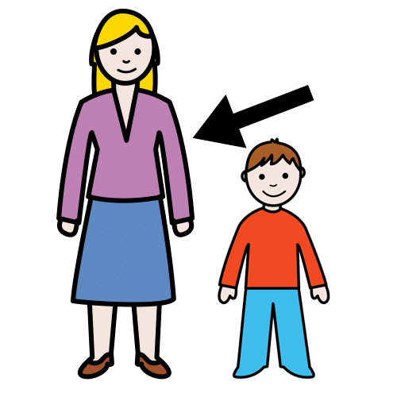
Are they 18 or older?
Put an X in the right box.

Yes

No

Have they won the award?
Put an X in the right box.

Yes

No


Please tell us


There are 3 long questions.

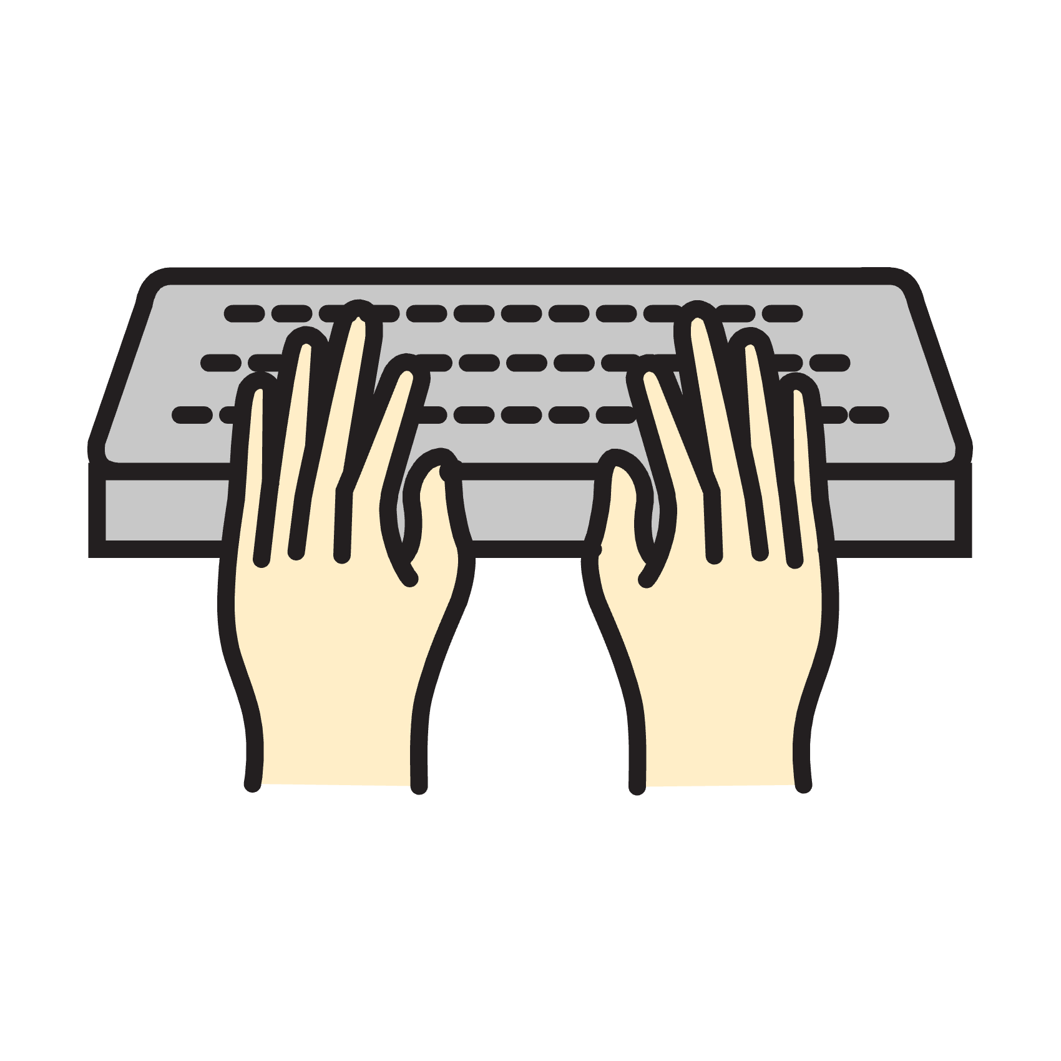
It can be 150 words

or
2 minutes.


This person has done great work.
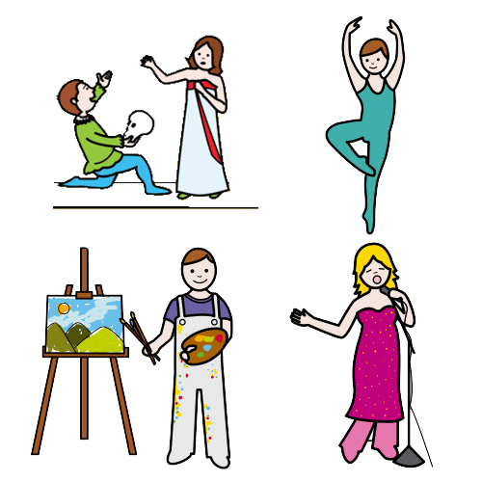
Tell us about it.
Type here

The award will help
- Job

- Feel proud
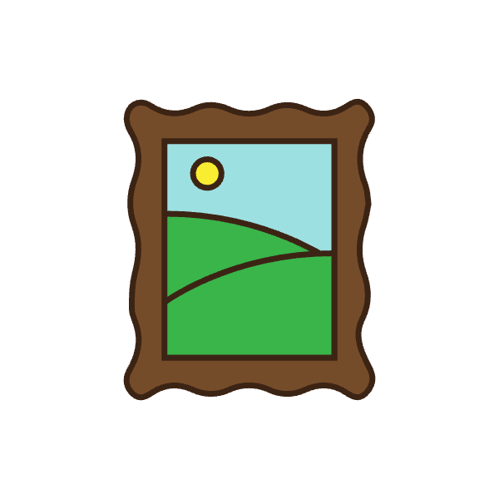
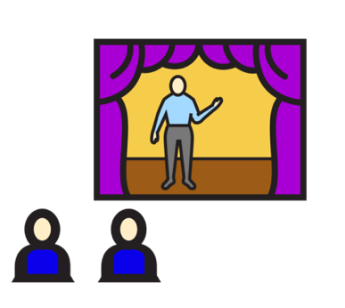
- Art to be seen.
Type here


How has their work been good for others?
Type your answer here.

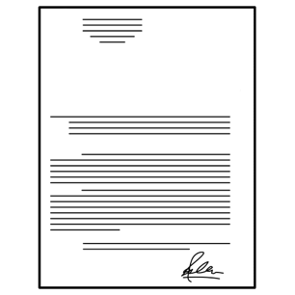
I will send
- CV

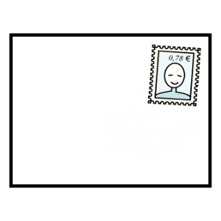
- Web links
- Letter
- Headshot.


I agree

I have read the guide.

All my answers are true.

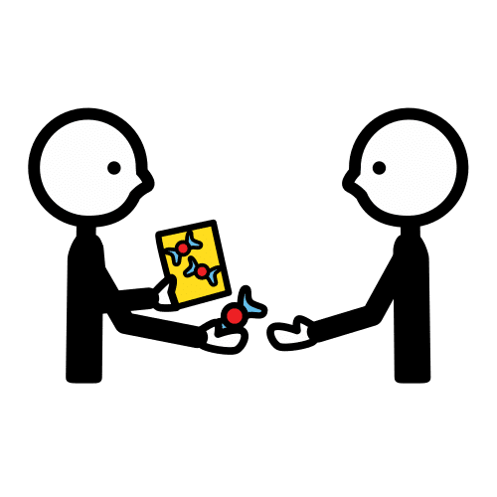
It is okay to share this art.

They know I will nominate them.

They will say they are
- Deaf
or
- person with a disability.

They can go on our
- Website
- Facebook
- Report.

They will talk about it in their
- CV
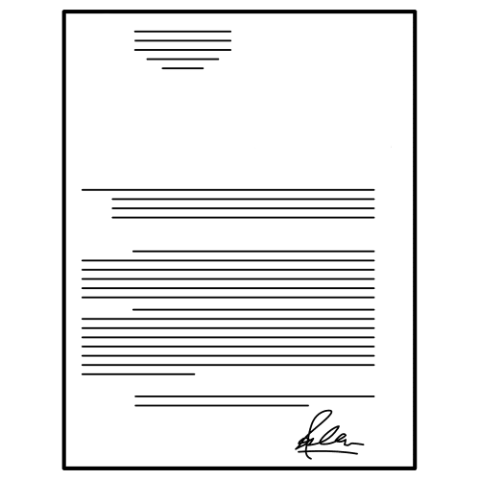
- Website.

My name is

Type here


I will sign my name.


Date
Type Date here

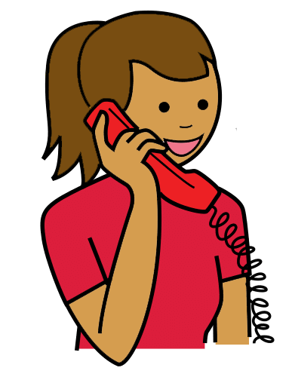
You can talk to us

You can ask a question.

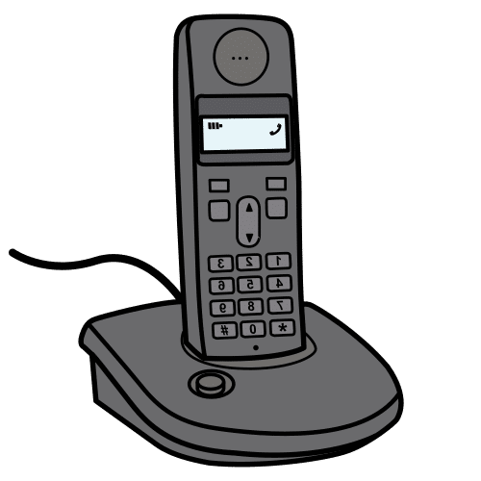

You can call
1800 275 753


Email
info@accessarts.org.au
and
tim.brown@accessarts.org.au

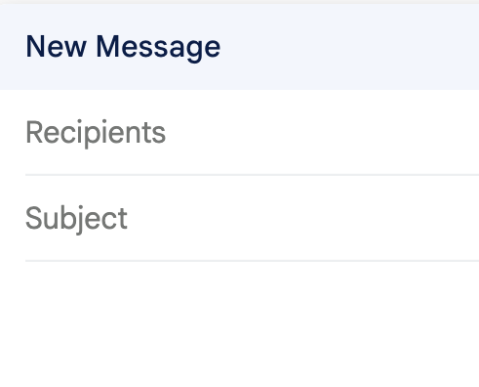
The subject is Access Arts Achievement Award 2026

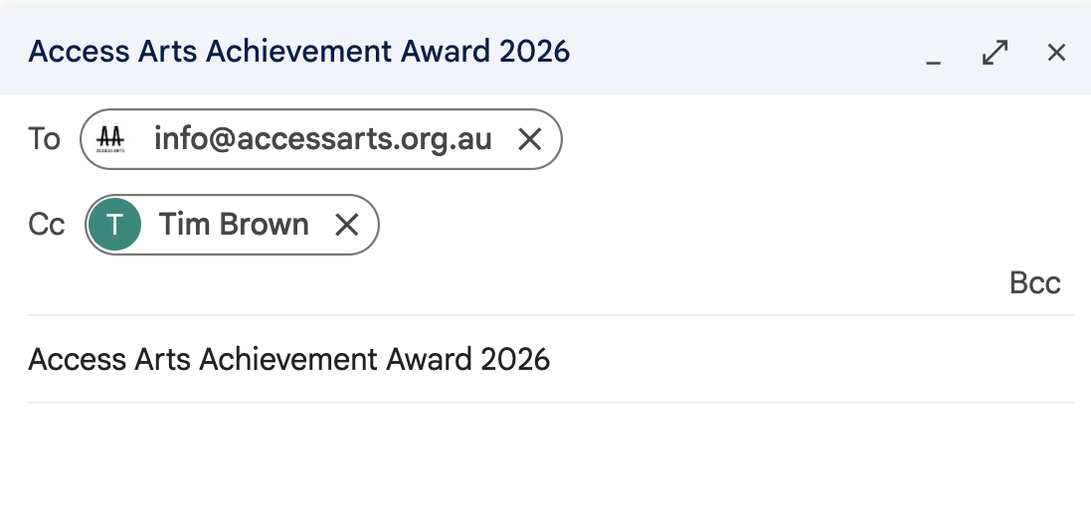

This is based on the Access Arts Achievement Award Form.

Alexandra Ellis at Always Access wrote this Easy English document.
alex@alwaysaccess.com.au
September 2026

Images
Global Symbols
Vecteezy

