About

Access Arts SAFE Grants provide flexible assistance to emerging and professional artists and arts workers living in Queensland who experience disability and/or who are d/Deaf.

Access Arts awards SAFE Grants of up to $1,000 (excl GST) to support artists create, develop, produce, exhibit and/or tour their work. Applicants working in all areas of the arts are eligible to apply, such as producers, writers, or curators.

SAFE Grant Recipient 2024

A.S. Venetsianova-Rubenstein

SAFE Grant supported artist A.S. with ‘‘My Chickens and Cats’.

Building on the success of her beloved artwork, Husky Wusky under the Mock Oranges, A.S. will create a new collection of mixed-media works exploring the theme of her cherished chickens and cats

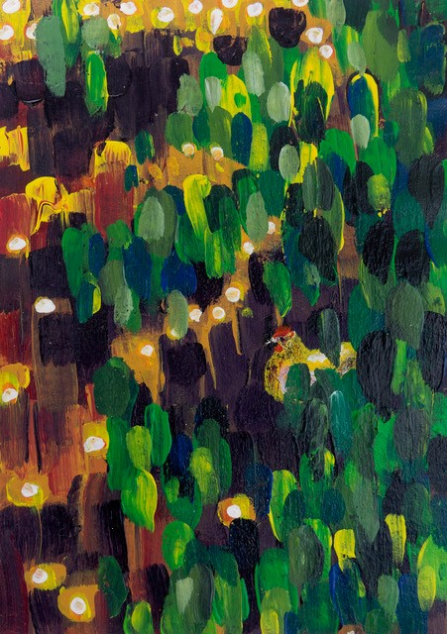

Applications are considered on a rolling basis, there is no application closing date.

**See how other artists have benefited**: [SAFE Grant Recipients - Access Arts](https://accessarts.org.au/what-we-do-to-help/grants/safe-fund/safe-grant-recipients/)

Eligibility Criteria

|  |
| --- |
| To be eligible you must: |
| 1. Be an emerging or professional artist, arts worker or producer who identifies as experiencing disability and/or who is d/Deaf. |
| 1. A Queensland resident. |
| 1. An Australian citizen or Australian permanent resident 18 years of age or over. |
| 1. You must not be a previous winner, artists may only receive a SAFE Grant once. |
| 1. Consenting to identify publicly as a person with disability. |

|  |  |
| --- | --- |
| The funding can be used for,  but is not limited to: | The funding may not be used for: |
| * Mentoring or tutoring to assist with reaching specific artistic goals. | * Any competition or fundraising activity |
| * Attending conferences, projects, workshops, training or events which will have a direct and lasting impact on your artistic development. | * Retrospective expenses |
| * Setting up an arts-related business |
| * Equipment to assist with working in the arts industry. |
| * Travel and accommodation assistance for artists and/or their support person to attend artistic development events. |
| * Access costs, or costs of making the activity accessible to a wider audience (eg Auslan, captioning, audio description, other formats). |

Project Criteria

|  |  |
| --- | --- |
| Applicants will be assessed based on the following selection criteria: | |
| Provide a detailed description of your proposed project, outlining the specific activities that will be involved?   * Tell us what you want to use the grant money for (training, mentoring, travel, etc). Give as many details as possible. |
| In what ways will this project contribute to the support and development of your artistic practice?   * Let us know what you want to achieve in your professional goals and how this grant could help you get there. |
| Do you anticipate utilising this funding, or the purpose for which the funding will be used, to support access needs? |

You may find it helpful to talk over your SAFE grant proposal with our Arts Manager Tim Brown before you submit your application. Please call 07 3505 0311 to make an appointment.

Budget

There is a Budget template within the Application form, however you are welcome to submit your budget as a separate document if you prefer. The Budget template is a guide to help you develop your proposal, please ensure your estimates are in whole dollars.

While you can apply for up to $1,000 maximum, you may only require a smaller amount to complete your project successfully. Applicants who apply for less will not be disadvantaged.

Support Material

Your supporting material is part of your application, please provide the highest quality where possible. For your application to be eligible, you must submit your current resumé and examples of work specific to the project or activity for which you are applying.

We only require material that is listed below; any additional material will not be assessed.

|  |  |
| --- | --- |
| Support Material | Items |
| Current Resume (required) | 1-2 pages maximum  Outline your artistic background, experience and achievements |
| Examples of work (required) | You may select any or a combination of the following:   * up to 3 pages of written material (published writing, research or press) * up to three online website online links to documentation of your recent work (blogs, news articles, other multimedia content) * up to 6 photographs or images of your recent work.   + photographs in .jpg format * up to 10 minutes of video or sound recording of your recent work   + links to video files should be between one to ten minutes in .mp3, .mpg4, .mov or.wmv formats |
| Letters of support (optional) | You may provide up to three support letters:   * from individuals or organisations who know your work and commend it, and/or who have offered in-kind or financial support |
| One high resolution headshot photograph (required) | You may provide a high-resolution headshot photograph in .jpg or .jpeg format. Image must be in portrait orientation |

How to Apply

You can apply by downloading the application form.

SAFE Grant Recipient 2024

JESSE JONES

Jesse Jones presented Self & Survival in November 2024. This was his debut solo exhibition showcasing 12 vivid pop-art and surrealist paintings.

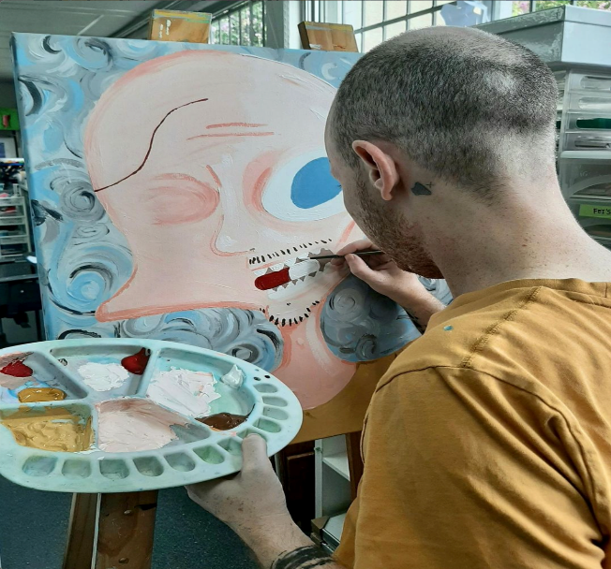

The maximum file size for sending an email to Access Arts is 15MB. If your application exceeds 15MB your application will not be eligible.

Step 1

Complete the application form and prepare your supplementary material. Don’t forget to include your budget.

Step 2

You are welcome to submit your application in a format that is accessible to you (such as audio, video, printed, dictated, electronic and handwritten). Please contact Access Arts to discuss specific format requirements.

* You may find it helpful to talk over your SAFE grant proposal with our Arts Manager Tim Brown before you submit your application. Please call 07 3505 0311 to make an appointment.

If successful

Your full SAFE Grant application will be assessed within four weeks of submission. We will then write and tell you whether your application is successful.

Final Report

Within four weeks of your project being completed, you will be required to send us a final report telling us what the SAFE Grant has done for you and your artistic practice. This will also include a high-quality image of your creative project or practice.

We also require receipts for the items you have spent the Grant funding on. Access Arts will hold 5% of the SAFE Grant money until we have received your final report and receipts. Further guidelines will be sent to successful applicants.

Acknowledgement

* Applicants retain the intellectual copyright of their project.
* Successful applicants must acknowledge Access Arts in all promotional material relating to the SAFE Grant and include the Access Arts logo whenever feasible.
* Access Arts reserves the right to showcase information about projects funded through a SAFE Grant on the Access Arts website, in the media, and for promotional purposes. This may include the artist's name, image, project summary, and provided quote.

Contact Details

**Email:** [info@accessarts.org.au](mailto:info@accessarts.org.au?subject=SAFE%20Grant%20Application) with **SAFE Grant Application** in the subject line.   
Please cc [tim.brown@accessarts.org.au](mailto:tim.brown@accessarts.org.au) into your email.

**Phone:** 07 3505 0311 | Monday – Thursday | 9am – 5pm