About
Access Arts SAFE Grants provide flexible assistance to emerging and professional artists and arts workers living in Queensland who experience disability and/or who are d/Deaf.
Access Arts awards SAFE Grants of up to $1,000 (excl GST) to support artists create, develop, produce, exhibit and/or tour their work. Applicants working in all areas of the arts are eligible to apply, such as producers, writers, or curators.
Applications are considered on a rolling basis, there is no application closing date.

Eligibility Criteria
To be eligible you must:
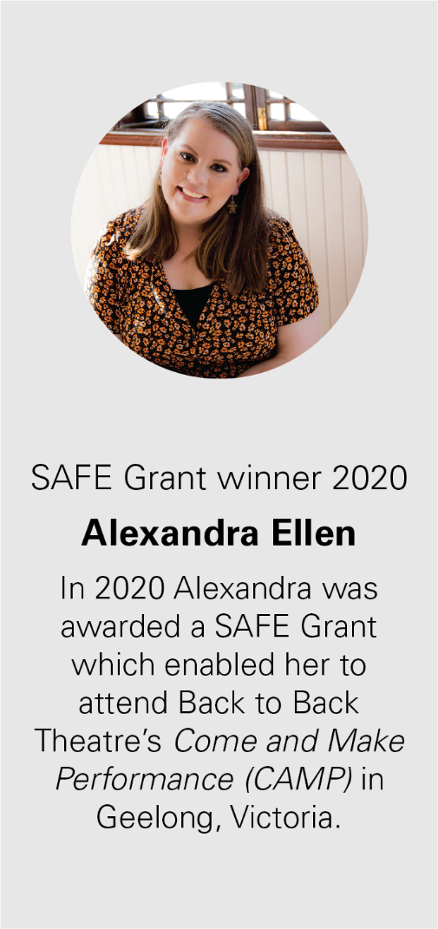
- Be an emerging or professional artist, artsworker or producer who identifies as experiencing disability and/or who is d/Deaf
- A Queensland resident
- An Australian citizen or Australian permanent resident 18 years of age or over
- You must not be a previous winner, Artists may only receive a SAFE Grant once.

The funding can be used for, but is not limited to:
- Mentoring or tutoring to assist with reaching specific artistic goals
- Attending conferences, projects, workshops, training or events which will have a direct and lasting impact on your artistic development
- Setting up an arts-related business
- Equipment to assist with working in the arts industry
- Travel and accommodation assistance for artists and/or their support person to attend artistic development events
- Access costs, or costs of making the activity accessible to a wider audience (eg Auslan, captioning, audio description, other formats)

The funding may not be used for:
- Any competition or fundraising activity
- Retrospective expenses

You should demonstrate that funding or in-kind support is being contributed from other sources, in addition to the SAFE Grant, or that you are working in partnership with Access Arts to apply for additional funding or support

Project Criteria
Applicants will be assessed based on the following selection criteria:
- What is your proposed project? What activities will be involved?
- How will this project support and develop your artistic practice and further your professional goals?
- What are the barriers you might experience in undertaking this project?

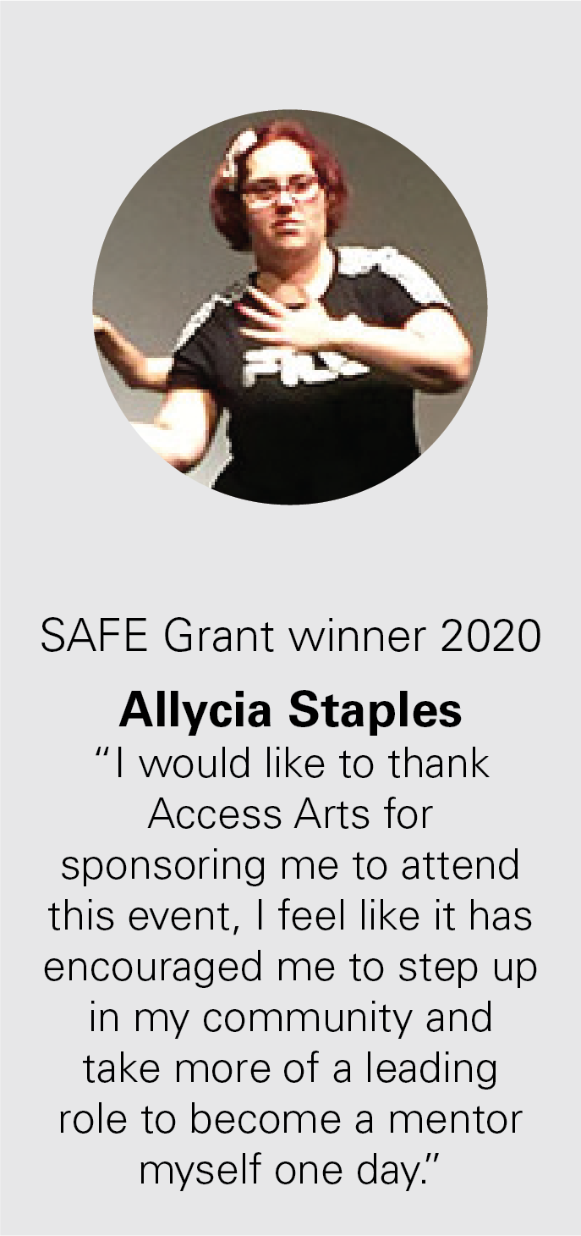
Support Material
In addition to your application, you must provide:
- Current resume (required)
- Examples of your work (required)
- Letters of support from individuals or organisations who know your work (optional)

Budget
There is a Budget template within the Application Form, however you are welcome to submit your budget as a separate document if you prefer. The Budget template is a guide to help you develop your proposal, please ensure your estimates are in whole dollars.
While you can apply for up to $1,000 maximum, you may only require a smaller amount to complete your project successfully. Applicants who apply for less will not be disadvantaged.

How to Apply
Step 1
Complete the application form and prepare your supplementary material. Don’t forget to include your budget.

Step 2
Email your completed application form and support material to info@accessarts.org.au.
You must cc tim.brown@accessarts.org.au into the email with SAFE Grant Application in the title.
Your email submission should not exceed 15MB or your application will not be eligible.
You are welcome to submit your application in a format that is accessible to you (such as audio, video, printed, dictated, electronic and handwritten). Please contact Access Arts staff to discuss specific format requirements.
You may find it helpful to talk over your SAFE grant proposal with our Arts Manager Tim Brown before you submit your application. Please call 07 3505 0311 to make an appointment.

If successful
Your full SAFE Grant application will be assessed within four weeks of submission. We will then write and tell you whether your application is successful.

Final Report
Within four weeks of your project being completed, you will be required to send us a final report telling us what the SAFE Grant has done for you and your artistic practice.
We also require receipts for the items you have spent the Grant funding on. Access Arts will hold 5% of the SAFE Grant money until we have received your final report and receipts. Further guidelines will be sent to successful applicants.

Acknowledgement
Applicants retain the intellectual copyright of their project. Successful applicants must acknowledge Access Arts in all promotional material relating to the SAFE Grant and use the Access Arts logo wherever possible.
Access Arts reserves the right to release information about projects funded through a SAFE Grant to the media and for other promotional purposes.

Contact Details
Email: info@accessarts.org.au with SAFE Grant Application in the subject line.
Please cc tim.brown@accessarts.org.au into your email.
Phone: 07 3505 0311

