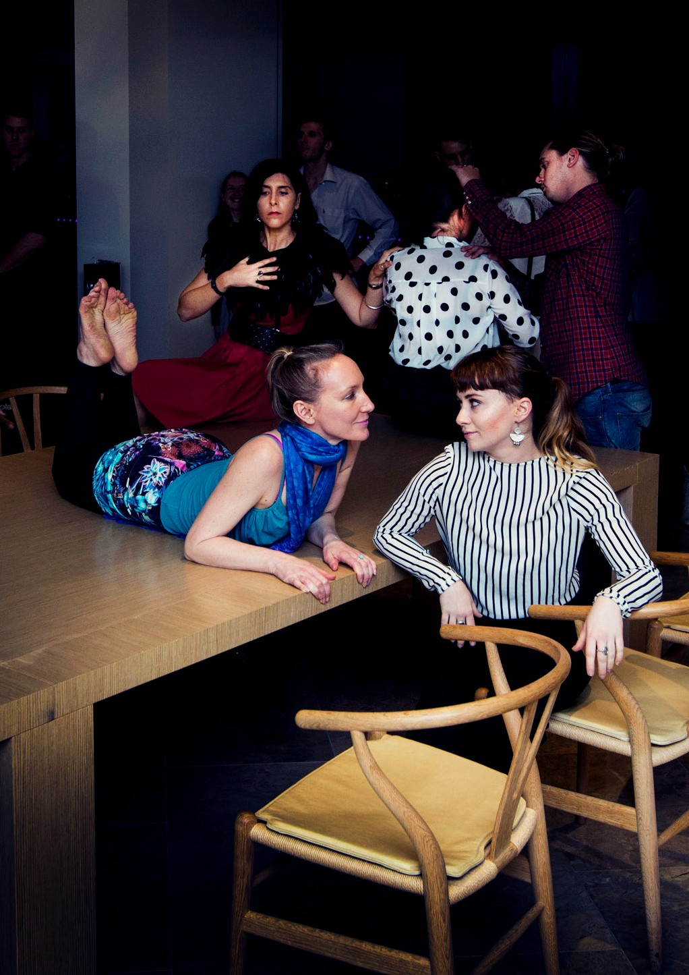We believe the arts are for everyone

ANNUAL REPORT
2015
Access Arts Annual Report 2015

Access Arts
ABN 82 066 160 761

Street Address
Postal Address Phone
Local Email Website
Unit 7, 65-69 Macgregor Terrace
BARDON QLD 4065

PO Box 823
PADDINGTON QLD 4064

(07) 3505 0311
1300 663 651
info@accessarts.org.au www.accessarts.org.au

Cover: Theatre Ensemble performed At The Table for a captive audience at Perception Exhibition in September 2015.

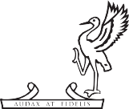Proudly supported by the Australian Government

2 Access Arts Annual Report 2015

Contents

4 Our Story

8 Chief Executive’s Report

12 President’s Report on Performing Arts Program

14 Undercover Artist Festival

16 Perception Exhibition

18 Rhythmic Palette

20 Have Your Say

22 Access Arts Achievement Award

24 SAFE Fund Grants

- President’s Report on
Indigenous Advancement Strategy

- Giving Back to Access Arts

- President’s Report on Management Committee

- President’s Report on Staff

- Treasurer’s Report

our story

Access Arts has been working to support artists with disability or disadvantage for over 30 years. We believe that everybody deserves quality access to arts activities and the opportunity to work towards a career in the arts.

Our work is widely recognised and our artists excel across all art forms. We also reach out to the community, listen to what people want and provide professionally facilitated arts workshops that give our members a creative outlet.

2015 was our best year ever and we achieved many of our major goals on time and on budget with a small but highly dedicated team.

A YEAR OF FIRSTS

Take a look at some of our achievements:

- We organised the first disability arts festival in Queensland.

- We launched our Theatre Ensemble which already has three public performances to its credit.

- We led our first Creative Ageing project for Lutheran Community Care.

- 95 artists with disability participated in Access Arts programs.

- 150 artists with disability participated at Undercover Artist Festival.

- 17 of our visual artists exhibited their work professionally.

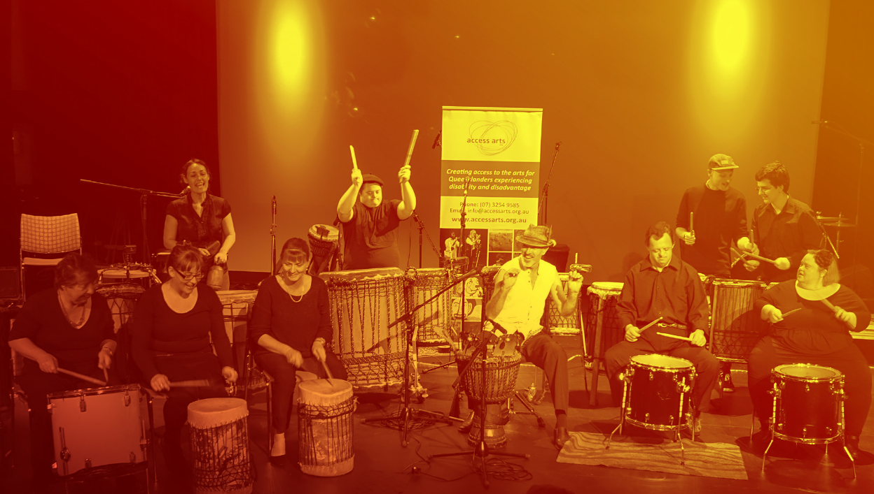
Access Arts Drummers
performing at Talkin’ the Drum at BEMAC
Photo above: Access Arts Drummers performing at Talkin’ the Drum at BEMAC

OUR PURPOSE

We are passionate about pioneering opportunities for people who experience disability or disadvantage, empowering them to excel in the arts.

We work with artists throughout Queensland, helping them to develop their practice. In all art forms at all levels we uphold our vision that everyone is free to enjoy, participate, create and work in the arts.
Over three decades we have become one of Australia’s acknowledged leaders, inspiring the cultural sector to break down barriers and change lives.
We broker strong regional, national and international partnerships to help us deliver our vision.

Our services include:
- Community arts programs for people with disability
- Professional development opportunities for artists with disability
- Bespoke arts workshops for disability organisations
- Creative Ageing: arts programs commissioned by aged care providers
- Access Services: audits, planning and disability awareness training for all organisations

ENGAGEMENT

Through our membership we collaborate and consult with artists with disability and the community to deliver programs that help nurture and develop creativity and give people a sense of purpose, to drive social change.

Our small but dedicated team includes practicing artists across all art forms who understand and work in the sector. They help create opportunities and manage successful programs with passion and integrity.

Our valued partnerships with organisations and individuals in the not for profit, arts, government and corporate sectors are crucial to the success of our work – our network is our strength.

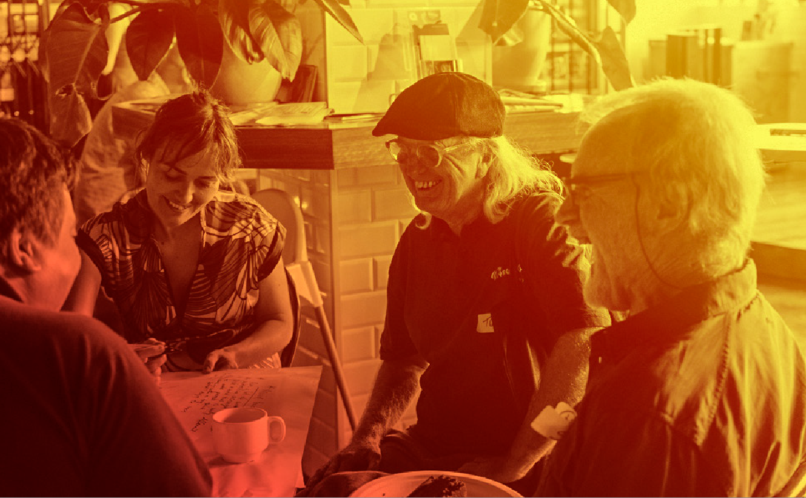
Harmonie Downes, Tony Robertson, Peter
Vance and David Truong (clockwise) at the
Access Arts Performing Arts Community Cafe

Photo above: Harmonie Downes, Tony Robertson, Peter Vance and David Truong (clockwise) at the Access Arts Performing Arts Community Cafe

Chief Executive’s Report

In 2015 Access Arts delivered on many of the remaining measures that we set out in our 2014-2016 Strategic Plan.

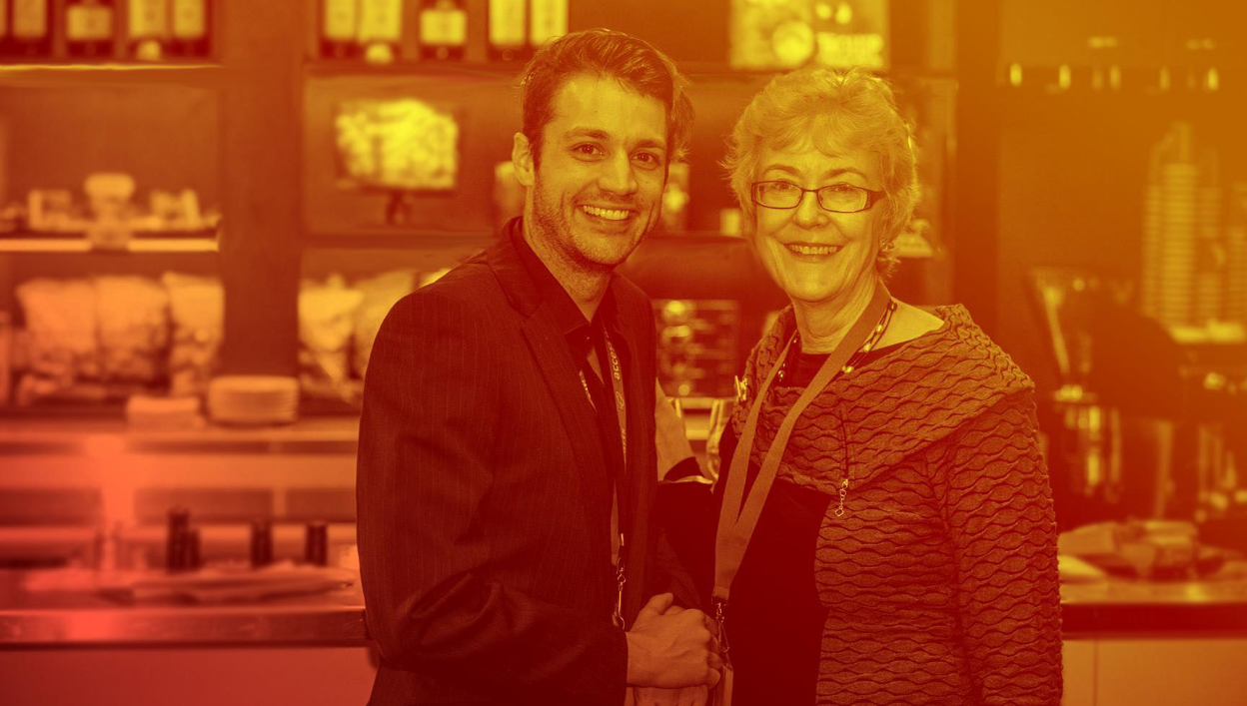

Photo above: Tim Brown, Project Coordinator of Access Arts, and Pat Swell, CEO of Access Arts.

Great Art

Our performance measure – to have enabled an iconic disability arts festival in Brisbane.
Undercover Artist Festival, Queensland’s first ever disability arts festival, was a signature event. It drew artists and audience members from across Australia and New Zealand.
With its high curatorial vision it exceeded expectations.

Our performance measure – to have grown Queensland’s performing arts infrastructure for people with disability.
Through our packed three-month performing arts program we established theatre and music ensembles led by some of Brisbane’s greats - Margi Brown Ash and Annie Peterson. We hosted a master class led by iconic international trumpeter James Morrison. We ran dance residencies in Moreton Bay and Brisbane bringing Australia’s leading company Dance Integrated Australia to Queensland. We supported two artists to attend iconic Back to Back Theatre’s CAMP.

And we enabled Melbourne-based Auslan Stage Left to run a weekend workshop to skill up Queensland Auslan interpreters in the complex art of translating for the stage.
Our performance measure – to have continued to develop our year-round arts program. Our energetic visual artists exhibited in many exhibitions in 2015 including Brisbane Festival. Perhaps the highlight was our prestigious annual exhibition held overlooking the Brisbane River at KPMG’s magnificent offices, where our visual artists sold more artworks than in any previous year. This was the third year of our significant exhibition partnership with KPMG. Our community arts program reached new heights: our two showcases - Wonderland Revisited and Rhythmic Palette – testified to the high standard of work our members achieved.“Our visual artists sold more artworks than in previous years”

Great Access

Our performance measure – to have developed our Access Services.
We undertook the first part of an Access Appraisal for Scenic Rim Council, commented on State Library of Queensland’s draft Disability Action Plan 2016-18, and completed our first Creative Ageing project in aged care through forging an exciting new partnership with Lutheran Community Care.

Our performance measure – to have developed paid employment opportunities for people with disability.
Paid engagements we brokered for our artists during 2015 included performances at Kingscliffe TAFE’s Career Expo Connect to your Future and State Library of Queensland’s ALLtogether celebration. We ended the year commissioning, on behalf of
the National Disability Insurance Agency, our artists to perform at the prestigious national NDIS New World Conference.

“Demonstrated a satisfaction rating well in excess of 90%”

People Focussed

Our performance measure – to have extended our reach.
We developed our links in Far North Queensland. We worked with Indigenous circus group Blackrobats in Kuranda, and supported our inaugural Access Arts Achievement Award-winner Doug Robins to have the first creative development of his work Doug is Hamlet with JUTE Theatre Company, Cairns.

Our performance measure – to have deepened our knowledge of what our members think and want of our services.
The year began with a Performing Arts Community Café where our sector advised on the performing arts program and festival. Using people-centred personal development plans and surveys we listened to our members, and developed a deeper understanding of the cultural impact of Access Arts through an external consultancy by Culture Counts.

Our performance measure – to have developed tools to evidence the social impact and artistic vibrancy of our work.
We were honoured to be one of only eight organisations selected by Arts Queensland to take part in the pilot undertaken by global leaders in cultural measurement, Culture Counts. Their work gave us peer feedback and valuable insight into facets of our social impact and artistic vibrancy, furthered our understanding of members’ aspirations, and demonstrated a satisfaction rating well in excess of 90%.

Resilient Organisation

Our performance measure – to have reviewed our policies, procedures and financial systems. Work advanced to strengthen our practices and improve compliance with the Human Services Quality Framework against which we are regularly audited. We also made significant strides towards improving our financial robustness.

Our performance measure – to have diversified our funding base and increased turnover. In 2015 we heard that our application for Indigenous Advancement Strategy funding from Australian Government through the Department of Prime Minister and Cabinet was successful. Access Arts was selected along with fewer than 1,000 applicants across Australia from applications numbering in excess of 24,000. This funding will enable us to continue our important work with First Australians in Queensland for the next three years. Private sector income increased significantly on the previous year in part due to very generous donations and in part because The Creative Industries
Skills Council nominated Access Arts as sole beneficiary of its residual funds; the value of pro bono donations to Access Arts rose, we also tested ways to increase our earned income.

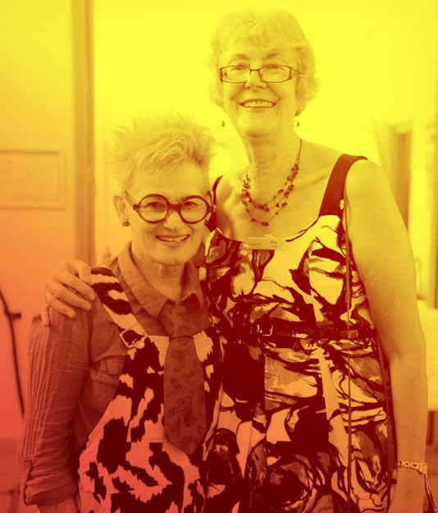I have touched on just some of the considerable achievements of 2015 and shown we are well on track to deliver our 2014-2016 Strategic Plan. These achievements testify to the dedication of our highly skilled Board led by President Thomas Bradley QC, our talented staff, our committed funders, partners, donors and supporters, and to the encouragement of you, our members.
Pat Swell and Margi
Brown Ash at
Rhythmic Palette
Thank you all,
Pat Swell, Chief Executive
Photo above: Pat Swell (right) and Margi Brown Ash at
Rhythmic Palette

President’s report on PERFORMING ARTS PROGRAM

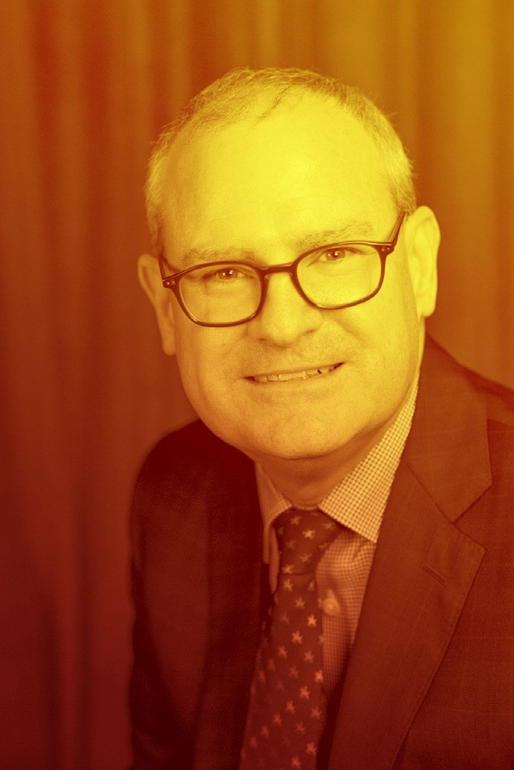
Photo above: Thomas Bradley QC, Access Arts President
Without doubt, the highlight of 2015 was the inaugural Undercover Artist Festival.
The festival, which took place at Queensland Theatre Company, was a result of the interest of Access Arts members in re-invigorating
our performing arts program, first expressed almost three years ago. The idea developed and gathered momentum blossoming into form on 26 and 27 June.

Over two days 150 artists across all art forms presented their work to more than 500 audience members.

The aim of the festival, and the associated performing arts program, is to foster and showcase exceptional work by emerging and professional artists with disability. It reminded us that exceptional art often has a social impact. The performances and exhibits showcased in the festival challenged, amused, provoked and entertained.

They also delivered the powerful message that when our members perform on stage they are not disabled, rather they are actors, dancers, musicians, singers and comedians. It also served to remind us that at the heart of every great performance is the generosity of the artists who share their talents for the benefit of audiences.

The great success of the festival may be attributed to the work of Belinda Locke, as founding festival director. Belinda is well-known to our members as a former Access Arts coordinator.

The opening party brought together many heavy hitters from the arts and disability sectors. At the Saturday morning sessions the interesting conversations begun the night before were explored more formally with panels and speakers.

Saturday afternoon brought performances by the major ensemble groups to large and enthusiastic audiences. On Saturday evening the mood changed again with sophisticated musical, theatrical and stand-up performances to “after dark” audiences.

The festival would not have been possible without generous external financial support:
- a special project grant from the Queensland Government through Arts Queensland;
- the support of the Australian Government through the Australia Council for the Arts, which secured the participation of Back to Back Theatre Company;
- a grant from the Moreton Bay Regional Council through the Regional Arts Development Fund for the residency of Dance Integrated Australia in North Lakes leading to their participation in the festival;
- the philanthropic support of the Ian Potter Foundation;
- and a generous donation in memory of former Access Arts performer and board member, Diane Hill.

I would also like to thank Queensland Theatre Company for so generously allowing
us to use their venue and for their invaluable support, Deaf Services Queensland for Auslan interpreting at the festival, Vision Australia for brailing of the programs, Auto & General Insurance Company for printing our promotional material, Cloveley Estate for the excellent wine for the Friday night opening and Expressions Dance Company, Metro Arts and Queensland Ballet, for opening their doors in the lead up to the festival.
We are also grateful for the contribution of the Queensland Music Festival and jazz musician James Morrison, who not only gave a master class to our newly- formed music ensemble, but donated a keyboard for the use of our musicians.
The Access Arts theatre ensemble, a product of the festival’s performing arts program, made three original and stunningly different public performances in 2015.
Late last year, Pat Swell and I met with Arts Queensland to talk about our desire to make Undercover Artist Festival a biennial event and to build a strong performing arts program to develop works during the “in between” years for presentation at the festival. With their encouragement, we hope to pursue that course.

UNDERCOVER ARTIST FESTIVAL

Date: 26-27 June 2015
Venue: Queensland Theatre Company
Proudly sponsored by QTC

Attendance: 500, including interstate visitors from South Australia, New South Wales and Tasmania.

Performances and exhibitions: 27, including caberet, comedy, costume play, dance, DJs, music, photography, spoken word, theatre, visual arts.

Participating artists with disability: 150, including artists from Cairns, Hobart, Dunedin, Christchurch and Perth; ranging in age from 18-70.

Media response: 2 Radio Interviews, 5 newspaper and online articles.
Organic reach on Facebook peaked on 24 June with the top post served to 8,713 people.
377 people liked the post and there were 1.1k clicks.
The Facebook video from the Dance Integrated Australia workshop scored 90 likes and 255 clicks. Twitter recorded 222 tweets including Undercover Arts Festival highlights, ticket sales, about Access Arts’ Vision.

Audience Comments:

Love it. I want more.

Thank you for making me feel, think and be inspired.

Life changing experiences do more of it! Open minds.

The festival has been run with extreme professionalism and the talent has been phenomenal.

Truly beautiful.

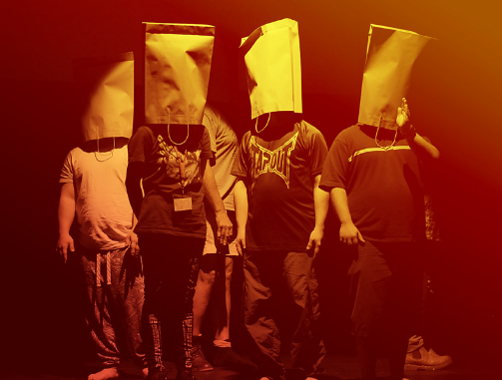
Photo Above: The Second Ensemble perform The Rite of Spring

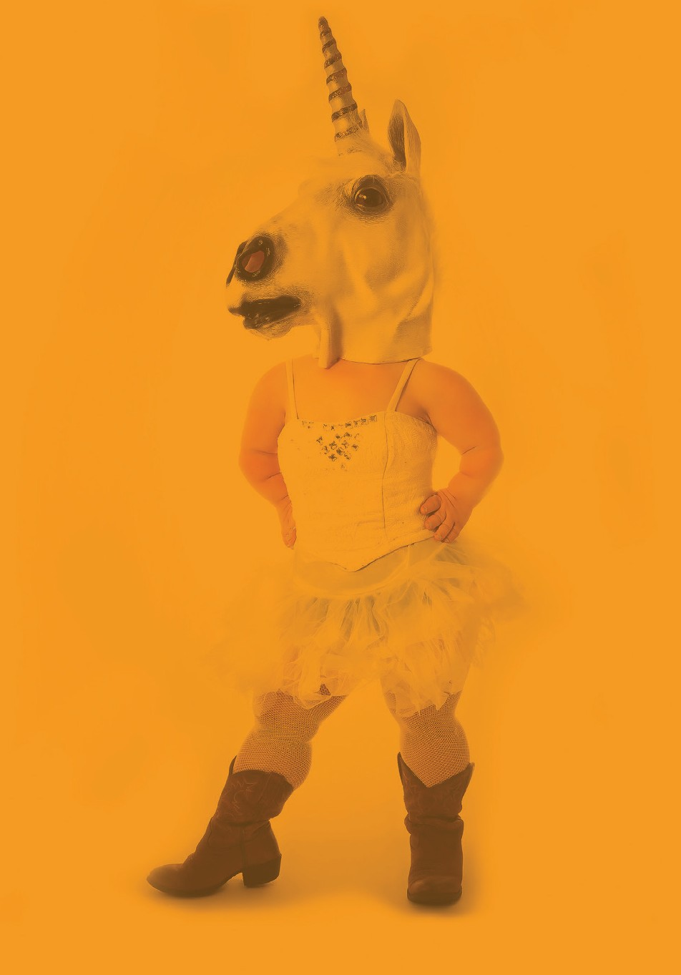

WE’RE HERE TO SHOW
AUSTRALIA WHAT WE’VE GOT
26-27 JUNE 2015
QUEENSLAND THEATRE COMPANY (07) 3010 7600 UNDERCOVERARTISTFEST.COM

Image by Amy Carter featuring Emma J Hawkins

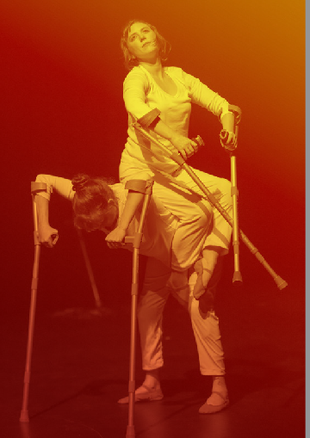
Photo above: Undercover Artist Festival Poster

Photo above: Hahna Briggs and Jenny Newstead perform From Conversation: Difference is Our Difference

Perception Exhibition

“Visual Art is still a key part of our portfolio and I am always delighted by the high standard of skills displayed by our visual artists. We greatly appreciate the support of KPMG for this annual event, which is part of the Brisbane Festival and also marked national Disability Action Week”
- Thomas Bradley QC, President Access Arts

Date: 17 September 2015
Venue: KPMG Brisbane Office
Proudly sponsored by KPMG

Exhibition details: Camera Wanderers and Brisbane Outsider Artists exhibited their work with a live performance by the Theatre Ensemble and visual artist Lisa Blake.
Number of artworks sold: 7
Sales totals: $1,500
Guests of honour: Our Patron, His Excellency the Honourable Paul de Jersey AC Governor of Queensland and his wife Mrs de Jersey
The Honourable Coralee O’Rourke MP, Minister for Disability Services, Minister for Seniors and Minister Assisting the Premier on North Queensland

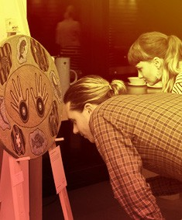
Photo above: Audience members captivated by the paintings

Comments:

I was very surprised and delighted not only to sell my artwork in the exhibition, but to also have two complete strangers come up and ask me to do a similar commissioned piece for them.
- Lisa Blake, artist

The Minister was very impressed with the quality and variety of artwork.
-Carolyn Nicholas,
Acting Chief of Staff to the Honourable Coralee O’Rourke

I loved the challenge of playing myself and not being ‘on stage’ - with the audience only a few steps away, allowing a rather intimate setting.
-Eleonora Ginardi, performer

It’s a great association for us which we will continue to support.
-Rob Jones, KPMG Queensland Chair

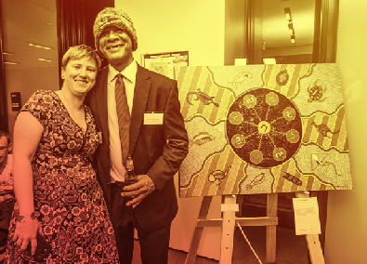

Photo above: Nadja Bielmeier and Bert Smallwood
enjoy the night by their artwork; painted by Bert
and owned by Nadja.
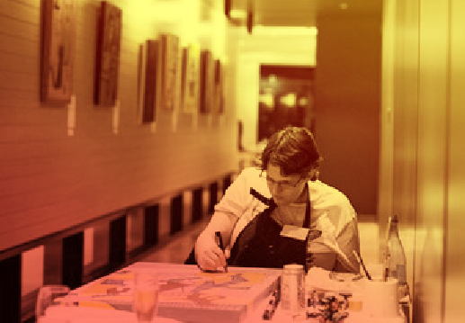

Photo above: Lisa Blake painting live during the event

Rhythmic Palette
The year ended with Rhythmic Palette, the traditional end of year showcase of the theatre, music, dance, spoken word and visual art works by our Access Arts members. We were pleased to have the Lord Mayor of Brisbane, Councillor Graham Quirk attend the showcase.
-Thomas Bradley QC, President Access Arts

Date: 28 November 2015
Venue: Kurilpa Hall, West End

Attendance: 123 members and community partners

Exhibition details: All Access Arts community workshops and professional development workshops exhibited or performed their art form, with special performances by CPL Screech Theatre and InsideOutside Theatre Company.

Number of Performances: 8
Guests of honour: Graham Quirk, Lord Mayor of Brisbane, and Councillor Helen Abrahams
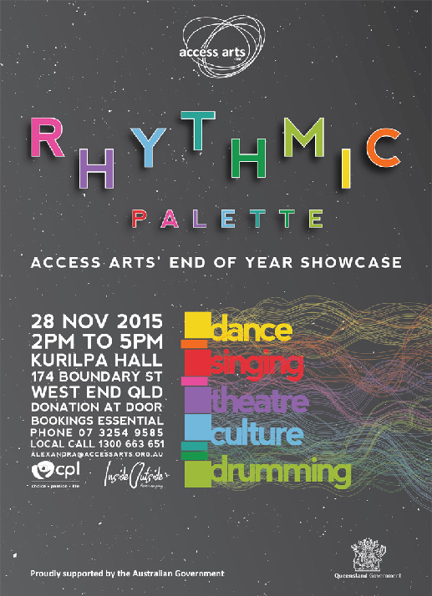
Photo above: Rhythmic Palette Poster

Comments:

Access Arts plays an important role in supporting those with a disability, their family, friends and carers.
-Graham Quirk, Lord Mayor

Keep up the terrific work and all the best for 2016
-The Honourable Jackie Trad MP, Deputy Premier of Queensland

Great to be part of Access Arts family.
-Audience member

Wonderful organization, very creative – Audience member
-Audience member

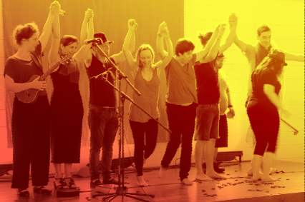
Photo above: Theatre Ensemble at the end of their group performance.

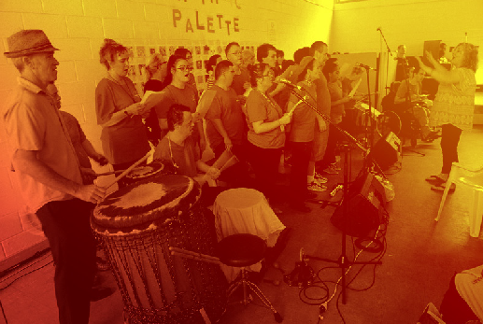

Access Arts Singers and Drummers performing.

HAVE YOUR SAY

Theatre Ensemble

Outcomes include (members) pleasure, excitement, finding some comfort with each other as they hit the floor running. Sharing stories was a fabulous experience seeing the actors relax into sharing and performing. There was a great sense of play, excitement and humour.
- Margi Brown Ash, Facilitator of the Theatre Ensemble

Music Ensemble

3 newly learnt songs were locked in for the performance in their final order: Vuma, Let it be and Spiral Blues. Member, David Truong fine-tuned his drumming patterns for Spiral Blues whilst other members Sandra, David W, Varinia and Chris continued to improve their vocals for Spiral Blues coming in on the chorus on time and in the right key.

Chris did really well to remember his lyrics considering that we rearranged the form and he was going from his memory with limited time spent on the song overall.

- Harmonie Downes, Arts Administrator and Facilitator of Music Ensemble

Professional Development

This was a great exercise as it put the focus on skill development to creating a performative outcome. It also meant we could witness what other workshops had taken place and have an insight into their processes and outcomes.

There are clear benefits for me as a practitioner attending CAMP. I felt I developed my artistic practice, skill set and vocabulary – I connected with other emerging artists, professional artists and Back to Back staff, and am able to bring all this learning and content back to Brisbane with the direct application to Access Arts Performance Ensemble.
- Daniele Constance, Professional Development recipient

Performing Arts Mentorships

I grew dramatically as a performer because of the direction of Sandro during this mentorship and the work he did on my acting and singing and movement. Working with Jeff Usher was also a wonderful experience as his professional outlook and interest in the project made for a polished performance from me. I learned much about how to do a cabaret in the most positive fashion, and we worked on different aspects of it every week.

Having feedback from industry professionals was invaluable and made for a truly dedicated performance from both Jeff and I.
- Karen Roberts, Mentorship recipient

Dance Integrated Australia Workshops

Every new project I feel very vulnerable with expectations to meet people’s needs. I have learnt to meet people with face value and I trust that the dancers will teach me how to teach them.
Everyone is the expert of being themselves. I encourage individually and expressiveness to come through. I am surprised at where we arrive in such a short amount of time…I would love to work with these people again. It is important to ask the question of what happens next.

There is a need in the community, are the people in the room able to have a voice and say this needs to continue? This vision I have for dance is to have more doors open for dance and be more inclusive. These are some of the best next generation of dancers in this country.
- Philip Channells, Creative Director - Facilitator of DIA Workshops

Access arts achievement award

The annual Access Arts Achievement Award provides funding for Queensland artists, artsworkers and producers with disability working in any art form to create, develop, present, produce, exhibit and/or tour their work.
The $10,000 Award is made possible by generous donation from Access Arts Life Member, singer/ song-writer Peter Vance.

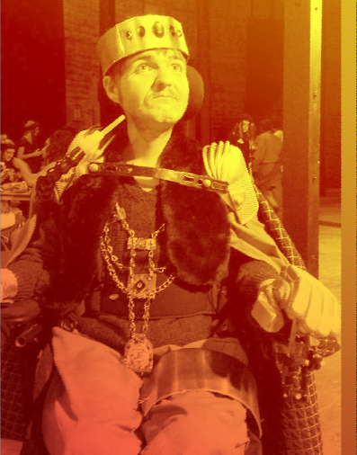
Photo above: Doug Robins
2014 Achievement Award Winner

Winning the inaugural Access Arts Achievement Award allowed Far North Queensland actor, Doug Robins, to take a significant step on his artistic journey. The funding went towards developing his next play Doug is Hamlet - a showing at JUTE Theatre in Cairns in March 2015 met critical acclaim.

My daughter gave me the inspiration and motivation to persevere in the creative industries. I am hoping to inspire other parents with chronic illness.

- Emma Le Strange, 2015 Achievement Award Winner

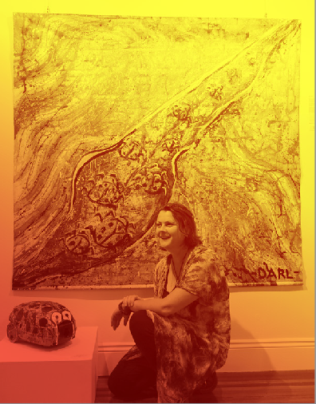
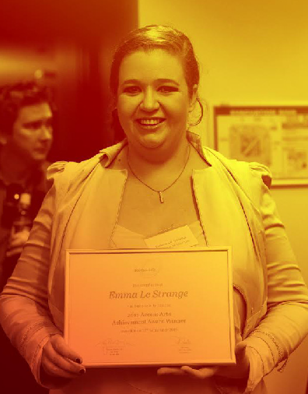
Photo: Tanya Darl Photo: Emma Le Strange
2014 Achievement Award Highly Commended 2015 Achievement Award Winner

Visual artist Tanya Darl was highly commended for her 2014 submission to the Access Arts Achievement Award. As a result in 2015 she planned and held her first solo exhibition, 5 ELEMENTS, at Graydon Gallery. The exhibition coincided with Mental Health Week and featured an original song by Access Arts member Peter Vance, who funded the Award. She was also able to learn new skills including marketing, curating and budgeting that will be essential to her success as an artist going forward.
Tanya’s work also featured at Within Without - a group exhibition with two other emerging artists, Alex Crombie and Belinda Peel at Graydon Gallery.

Artist and writer Emma Le Strange was the winner of the 2015 Access Arts Achievement Award, selected from an excellent pool of entries by our prestigious panel of judges.

Emma, who experiences chronic illness, will use her $10,000 award to produce a children’s book Tea Parties and Pillows. The story will follow the imaginations and creativity of a mother and daughter as they invent games to play on the days when Mum is not up to getting out and about.
Emma was frustrated by the lack of material available and inspired by her daughter, she started planning this light hearted book to demonstrate that no matter what obstacles life throws at you, you can still achieve your dreams.

SAFE Fund Grants

In 2015, Access Arts granted SAFE Fund grants to assist artists with disability in their professional development.

Singer Janelle Colquhoun was enabled to attend the Visually Impaired Musician’s Lives conference in London.

I have been able to bring back toAustralia many varied experiences to further my career …I am so grateful for SAFE fund to the assist in the costs of my trip.

- Janelle Colquhoun

The SAFE Fund Grant enabled Gillian Rankine to be mentored by Meredith Beardmore who travelled from Melbourne to play with her at the Early Music Society of Queensland concert, playing the Baroque Flute. Gillian reflects that this project enabled her to learn through a highly valuable performance experience in Brisbane.

A SAFE grant enabled Musician Mantist Oryem to print copies of his new single Hello Mamma to sell during live shows, at recording stores and on fans’ requests.

The SAFE Fund has been so helpful, giving me a chance to boost my career and take it to the next level. - Mantist Oryem

Within Without Exhibition was made possible by the SAFE Fund

A SAFE grant enabled Brisbane Outsider Artist member Belinda Peel to have an art exhibition which aimed to give her artistic exposure and to let other disability circles see her work.
Belinda has been working in the Brisbane Outsider Artists workshops at Access Arts for a large part of her career. Belinda sees some of the achievements were participants discovering the importance of gallery accessibility and its impact on a “society (which) is now more open to disability.”
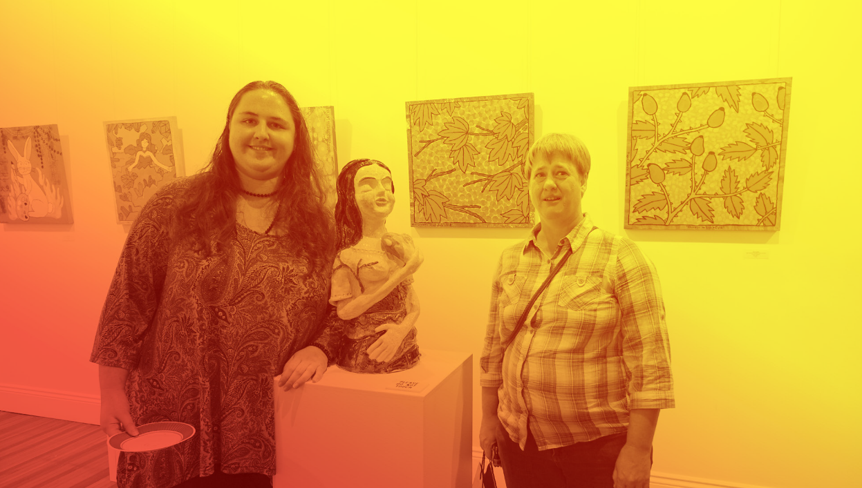
Alex Crombie and
Belinda Peel at their Within Without exhibition

Photo above: Alex Crombie and Belinda Peel at their Within Without exhibition

President’s report on
Indigenous advancement strategy

2015 also saw our long-standing relationship with the Australian Government supporting the work of indigenous artists transition from the Office of Aboriginal and Torres Strait Islander Health (OATSIH) to the Indigenous Advancement Strategy of the Department of Prime Minister & Cabinet.

We appreciate the contributions of the many members, supporters, collaborators and staff members, and are proud of the extraordinary body of work that has been produced by indigenous artists during a long and fruitful relationship. It means that Access Arts is able to continue working closely with our indigenous partners on a stream of work that has been an important part of our program for nearly 20 years.

In 2015: a story-telling project with Brisbane women from the Stolen Generation; and a circus skills development project with Blackrobats in Kuranda, Far North Queensland.

Thomas Bradley QC
Access Arts President

Giving back to access arts

We enable artists with disability or from a background of disadvantage to go from strength to strength, and we could not do it without you!

We would like to thank our donors for the contributions made in 2015. These funds are critical in building and sustaining our core programs such as community workshops, master classes, performance opportunities and exhibitions.

As a valued donor, you can engage with our artists and discover insights into their work by attending prestigious exhibitions and performances. You can support programs that will help our members overcome barriers and achieve highly developed artistic skills.

To donate today, please visit http://accessarts.org.au/get-involved/donate/

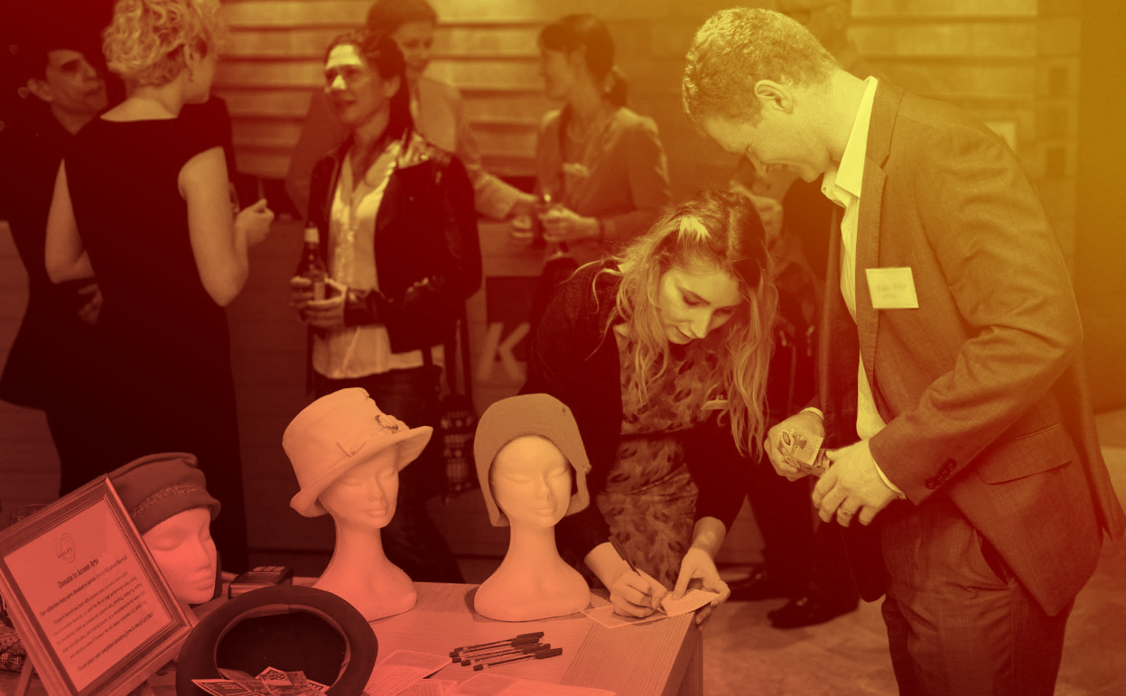
A supporter donating
money to Access Arts at
Perception Exhibition

Photo above: A supporter donating money to Access Arts at Perception Exhibition
President’s report on MANAGEMENT COMMITTEE

Earlier this year, Susan Ball announced that she would not be continuing as Secretary. Susan has served on the management committee since 2013 and as Secretary since 2014. In addition to an important role as the Client Services Manager of Muscular Dystrophy Queensland, Susan has applied her own extensive experience working with people with disability to help improve and develop person-centred policies and procedures to support members and their individual needs. Her input has made a real difference to the culture of Access Arts. I would like to thank Susan for her immense contribution, her generosity of spirit, and her wise counsel.

Patrick Tyro-Burns is also leaving the management committee. As we have been preparing for the implementation of the NDIS, Patrick has made a very valuable contribution to Access Arts with his extensive experience in disability services. He has also played a key role in establishing our relationships with current and potential partner organisations. With his strong background in policy, strategy and planning, Patrick has facilitated much of the key strategic planning activity. He has volunteered to continue in that role from outside the management committee. I am very grateful for Patrick’s timely and informed contribution to Access Arts.

I know that both Susan and Patrick will remain members and continue to contribute in important ways to the development of Access Arts as we make our way through the new and challenging terrain of the NDIS. Of course, their departures from the management committee will be balanced by the addition of two new members; so that, in a measured way, the process of organisational renewal continues.

I would like to record my particular appreciation of the work of our Treasurer Catherine Black, who has brought about a remarkable (and essential) upgrade of our financial accounting and reporting practices. I would also like to thank my fellow management committee members Liz Crawford, James Cunningham, Robert Hoge, Patrice McKay and Sam Nicolosi.

During 2015, the work of management committee members more than doubled with the implementation of three working groups on finance, capacity building and enterprise. As we move through another strategic planning process in early 2016, this increased workload is likely to continue. I greatly value the expertise, experience and effort the members bring to their roles on the management committee and the working groups.

Thomas Bradley QC
Access Arts President

President’s report on Staff

Staff changes
Under CEO Pat Swell, the Access Arts staff had a very busy year.

With Belinda Locke moving to Melbourne, we were pleased to welcome Timothy Brown into the project coordinator role for the performing arts. Angela Witcher of InsideOutside Theatre also joined the team as services and marketing coordinator. With Harmonie Downes moving into an arts administrator position, we welcomed firstly Tina Porter and now Alex Lawton into the role of administration assistant.

I would like to thank Pat and all her team, including the continuing veterans, finance and office coordinator Chris Collins, visual arts coordinator Rachel Gaffney-Dawson and arts administrator Harmonie Downes, for all their efforts over the year.

Change of scene
In December 2015 we closed the door on the Teneriffe chapter of the Access Arts story and began work on the next chapter at Macgregor Terrace, Bardon. If you haven’t visited the new premises yet, I encourage you to do so.

Thomas Bradley QC
Access Arts President

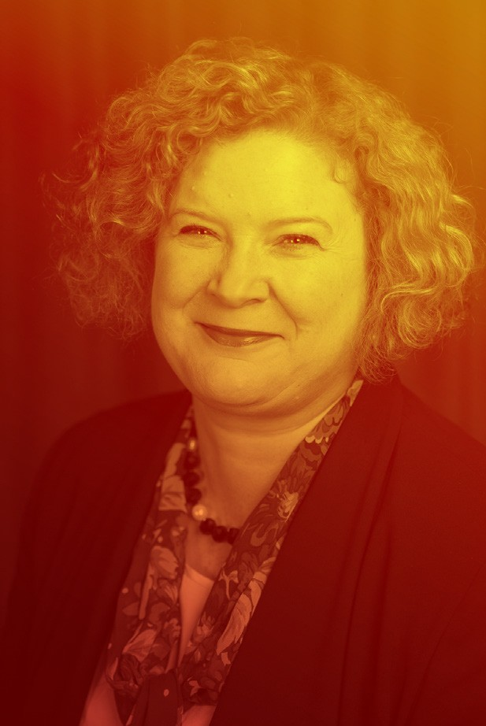
Treasurer’s Report

Photo above: Catherine Black
Access Arts Treasurer

I present the audited Financial Reports for the Financial Year ending 31 December 2015.

The annual financial statements have again been audited by Brian Tucker Accounting.

Access Arts returned a net profit of $13,563.56. Whilst this is a decrease on the 2014 figure of $55,035.81, higher costs were incurred in 2015 associated with the inaugural Undercover Artist Festival held in June 2015.

The Balance Sheet shows that cash at bank and term deposits amount to $250,295.81. These items include the funds set aside for the annual Access Arts Achievement Award ($40,000) and the SAFE Fund ($89,877.97). The funds for the Achievement Award and SAFE Fund are held for the purposes of providing the annual Award and grants respectively, so these funds are not available to meet general operating costs of Access Arts.

Total income was $760,061.45. Total expenditure increased to $746,501.27 (2014: $636,869.95). The larger items of expenditure related to the Undercover Artist Festival and general employee expenses.

There will again be some financial challenges for Access Arts in the coming year. At time of writing, there remains uncertainty about the future funding arrangements from a key supporter of the organisation. This uncertainty is associated with the introduction of the National Disability Insurance Scheme in Queensland.

In recent years, the budget process has been revised and updated to provide improved financial monitoring and reporting. This is an essential tool for good financial management. The Management Committee has been better informed and so able to plan more accurately. 2015 saw the establishment of a Finance Sub-Committee of the Management Committee. This Sub-Committee provides recommendations to the Management Committee and in particular, has refined the budgeting and financial reporting processes. The Sub- Committee and the Management Committee will continue to steward our resources and look for ways to improve the delivery of services to members.

The 2015 financial report will be available on our website.

32 Access Arts Annual Report 2015

We believe the arts are for everyone

www.accessarts.org.au

