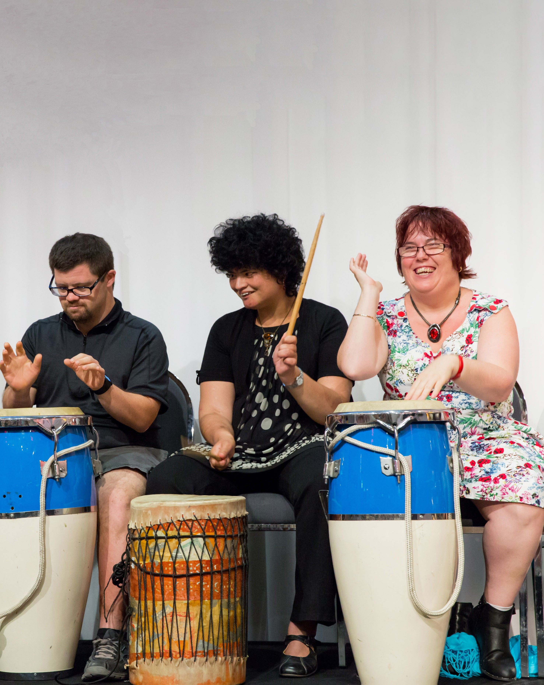Empowering Queenslanders who experience disability or disadvantage to take part and excel in the arts

ANNUAL REPORT
Access Arts Annual Report 2018 1
2018

Access Arts
Annual Report 2018

Contents

Page
- PRESIDENT’S REPORT 3
- CHIEF EXECUTIVE’S REPORT 6
- TREASURER’S REPORT 11
- A YEAR AT ACCESS ARTS 12
- OUR THANKS 17

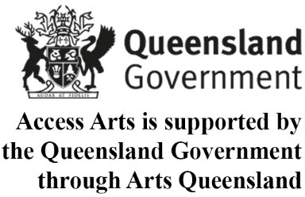
Cover Photo: David Waldie, Marisha Targett and Cindy Martin from Rhythm Circle

We believe the arts
Proudly Supported by the Australian Government
are for everybody

PRESIDENT’S REPORT
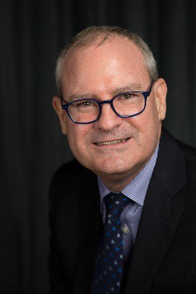
In 2018, across the country and across the globe, Access Arts members danced, yarned, sang, acted, played, painted, photographed, wrote, printed and shared their talents with more than 170,000 others. Congratulations to the Brisbane Outsider Artists, the Camera Wanderers, the Theatre and Dance Ensemble, the Rhythm Circle, the Access Arts Singers, the members of the Professional Artists’ Workshop, the participants in Leaps and Bounds, the song-writers and story tellers of the Western Downs, the dancers of Karul Projects and the fashion-makers who are dressing the Central West.

It was a particularly busy year for our visual artists with their work on display at the State Library, the Moreton Bay Region Art Awards, the Royal Queensland Art Society and Petrie Terrace Art Gallery, Brisbane Square Library, Pine Rivers Art Gallery, Ipswich Community Gallery, the Outsider Art exhibition by Art from the Margins, the Glow exhibition in King George Square, and in Tokyo at the Paralym Art World Cup.

Our performers, in their various disciplines, were on stage at the Powerhouse, the Judith Wright Centre of Contemporary Arts, the Cultural Forecourt at South Bank, the Upper Kedron Community Hall and at the grand opening of our annual exhibition generously hosted again at KPMG’s Riparian Plaza offices.

Congratulations are due to Carol Taylor, a water colourist from the Gold Coast, who won the 2018 Access Arts Achievement Award, which was again generously sponsored by Life Member Peter Vance.

All this is described in more detail in the accompanying annual reports.

The work of our members is the inspiration for the continuing contributions made by the members of the management committee to planning, managing and anticipating the impacts of changes in our operating environment, particularly with the National Disability Insurance Scheme.

In 2018, there was a lot of planning, managing and anticipating to be done. Our governance was reviewed. Our quality was audited. Our strategy was planned. We trained as ever on disability awareness and for the NDIS.

Here are a few high points.

We secured substantial additional support from Arts Queensland. This extra $150,000 a year gives us the chance to keep the extensive workshop program – the engine room of members’ work – operating into the future.

We examined proposals to become part of a larger group in the not-for-profit sector, so we can work together in a larger team to deal with the uncertainties the coming changes present. We have a very important proposal for the members to consider at the coming special general meeting, adding the support of CPL – Choice, Pasion, Life - to Access Arts and so bringing our long-connected histories even closer together. The management committee recommend the proposal, because it is a way to continue our important work many years into the future.

We continued to work with the State Library of Queensland as a partner, presenting the Meaningful Mandala between March and October.

We delivered, for I think the 25th consecutive year, programs in partnership with Indigenous communities and organisations across the State, including Dalby, St George, Brisbane, Barcaldine, Longreach and Winton.

Thanks to all our members for their work and inspiration. Thanks to the Access Arts team of staff in the office and at the workshops who deliver our services.

I would like to thank to all the management committee team. Special mention should be made of two members who are leaving the committee this year.
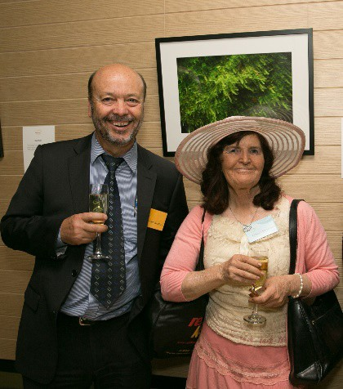

Outgoing Management Committee Sam Nicolosi with Camera Wanderers photographer Colleen Stevenson

Sam Nicolosi joined the newly elected management committee with me in 2013. He has been a consistent contributor to management committee discussion and decision-making and an enthusiastic attender of Access Arts events. With extensive experience in the training sector, Sam has been quite hands-on at times in getting our programmes and projects into a sensible order. His experience with IT and security issues gave us a much better-informed perspective on
these increasingly important matters. His engaging grin will be widely missed.
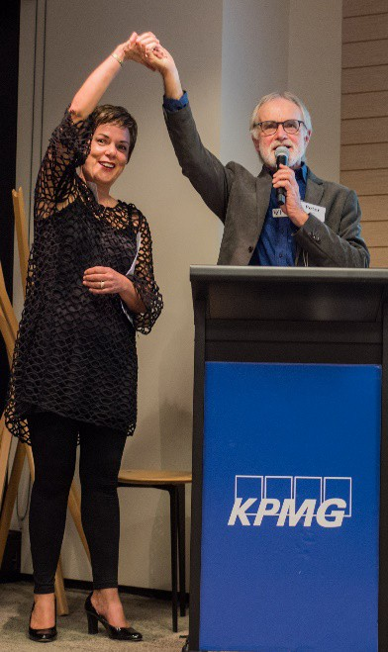

Outgoing Management Committee Secretary Liz Crawford and Access Life member Peter Vance

Liz Crawford has been on the committee since 2015 and has served three years as secretary from March 2016. Her organisational skills and deep experience in human resources added expertise and nuance in key aspects of our operations. Like most organisations, Access Arts is in the people business and the way we interact with members and staff is crucial to achieving our goals.

In both Sam and Liz one can recognise clear- sighted decision-makers. They have been exactly what we needed on the management committee as we navigated the shoals and reefs around the NDIS. I thank them most sincerely for their respective contributions. I trust that they will keep in touch with Access Arts, joining other management committee alumni as advocates for our cause.

It has been a challenging year for all on the management committee, and I acknowledge the contributions of each of the committee members. I would like to thank our Treasurer

Nicola Leahy for discharging the burden of that position.

We are very grateful for the on-going support from the Australian Government through the Department of Prime Minister and Cabinet for our Indigenous partnership work. We value the outstanding support from the Queensland Government through Arts Queensland for organisation funds and project funding; and block funding through the Department of Communities, Child Safety, Disability Services and Seniors. We also acknowledge the support of the Brisbane City Council through the Central Ward (Cr Vicki Howard), the Gabba Ward (Cr Jonathan Sri) and the McGregor Ward (Cr Steven Huang).
We acknowledge the generous support of corporate partners including KPMG and the State Library of Queensland, our pro bono partners including QAGOMA, Clayton Utz, Tonic Health Media, Deaf Services Queensland, our many philanthropic donors and our other arts and community organisation partners.

In 2018, our members have explored, renewed and grown their art practices. They have attracted new audiences, reviewers and patrons. I hope we have put in place a proposal that will allow Access Arts to continue to advocate for the importance of our members’ work over the coming years.

The Honourable Justice Thomas Bradley

President

CHIEF EXECUTIVE’S REPORT
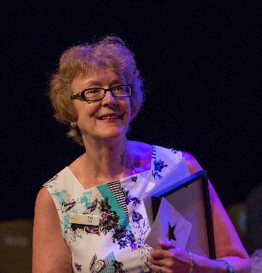

2018 Quick Facts:

  - 489 workshops delivered to

5,898 participants.
  - 31 public events, enjoyed by
  - 172,432 audience members.
  - 195 arts professionals benefitted,
  - $53,600 pro bono support attracted,

31% increase in private donations
over 2017.

Arts Workshop Program

“These workshops bring people together, provide mental and physical stimulation, a sense of belonging and community”

Our year-round weekly arts workshops - the engine room that provides creative and professional development for our artists to build their careers, make friends and socialise - are the bedrock of Access Arts’ programs. Throughout 2018 our workshop program developed and grew.

At our visual arts studio at Eight Mile Plains:
- Brisbane Outsider Artists (BOA) – continued to meet weekly on Mondays and Tuesdays
- Professional Artists’ Workshop – newly introduced on Wednesdays because there was no space for new artists to join us at BOA
- Camera Wanderers – found a home firstly at Reclink in Fortitude Valley, then we partnered with State Library of Queensland who gave our photographers
access to their state-of-the-art equipment at The Edge
- Mixed Media Visual Arts Workshops – due to demand we increased the number of weekly community visual arts workshops from one to two, and introduced mixed media. “It was delightful to see artists stretching the boundaries of their arts practice this year. An artist who ordinarily works with oils created a wooden bicycle; an artist who tends toward acrylics and pastels created a papier-mâché sculpture; an artist who predominantly paints in a semi-abstract style tried their hand at photo realism”.

We programmed our performing arts workshops at Brisbane Powerhouse Stores Building to take place all on the same day. As a result many people enjoyed not one but several Tuesday workshops.
- Theatre and Dance Ensemble – grew out of our Theatre Ensemble
- Rhythm Circle – our Drummers

Access Arts Singers
- Leaps and Bounds – a specially devised circus and dance workshop program that we ran towards the year-end in collaboration with Brisbane’s Vulcana Circus. We invited Blue Roo Theatre Company to join with us.

“I enjoy being in a creative space, meeting new people, using my creativity.”

Our 2018 arts workshop program with First Australians, usually delivered in partnership:
- Song-writing and Spoken Word on the Western Downs – with Sage Music and Goondir Health Services ‘Big Buddy’ program, artists Emily Wurramara, Yarum Dawson Sandy, MC Mooks (Geoffrey Granz) and Saraima Navara led workshops and performances for young First Australians living in Dalby and St George. “So good to see mob singing in language, these young ones are real leaders and setting a good example for our kids to be proud of their culture and to get up there and show it off….”

- For Your Spirit Soul - First Nations musician David Peacock underwent an intensive mentorship: “This project helped me rebuild my confidence and gave me motivation beyond the tiredness”. He performed at the July Musgrave Park NAIDOC celebrations and again in September before Access Arts’ Patron, His Excellency the Honourable Paul de Jersey AC Governor of Queensland at Access Arts’ exhibition at KPMG.
- Dress the Central West – a partnership with Red Ridge (Interior Queensland) started in November and will culminate in June 2019. First Australians from Barcaldine, Longreach and Winton began weaving their regional cultures and stories into different fashion pieces from recycled materials: “Spent a great day with a great group of people making wearable art with the insanely talented Claudia Williams”.
- Karul Projects – dance partnership with BlakDance Australia Ltd ended with Karul’s performance in December at the Judith Wright Centre of Contemporary Arts. “We want to be the QLD premiere Indigenous contemporary state dance company of Qld”

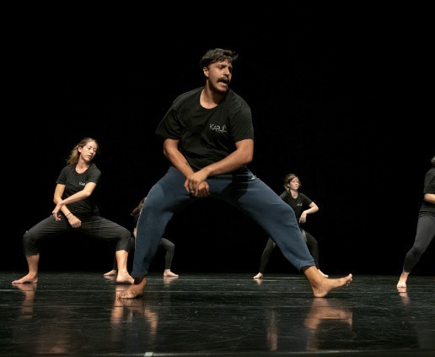
Karul Projects performing at the Judith Wright Centre of Contemporary Arts

Where are They Now?

Our $10,000 Access Arts Achievement Award-Winners
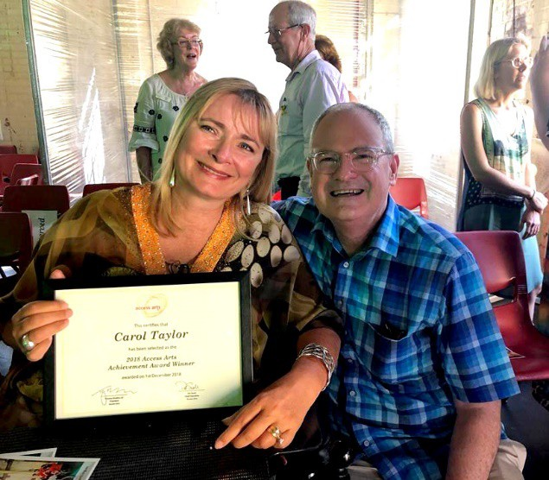
2018 Access Arts Achievement Award winner Carol Taylor with Access Arts President The Right Honourable Justice Thomas Bradley

With remarkable generosity, in 2013 our Life Member Peter Vance gave Access Arts
$50,000. With this Peter founded the Access Arts Achievement Award so that for the following five years one Queensland artist with disability could win $10,000 to make a significant difference to his or her artistic career. The Award was worth far more than just the monetary value. Access Arts brokered introductions and opportunities, giving each Award-winner mentoring and support on their career pathway.

Every year the Award attracted a distinguished Panel of Judges. Our 2018 judges were Weston Bruner, Director of Advancement at the University of Queensland; Liz Crawford, Partner, Derwent Executive; Tarragh Cunningham, QAGOMA Assistant Director; Erica Rose Jeffrey, Dance For Parkinson’s Australia. As in previous years Arts Queensland ran a workshop for aspiring applicants.

How did winning change each artist’s career?

- 2018 Award-winner - entrepreneurial Gold Coast watercolourist Carol Taylor: “I hope to use the Award to design clothes for people with physical disability using my artwork as a kind of ‘wearable art’”. Despite only winning the Award in December, before the year ended Carol had secured a place in Artisan’s BRISBANE ART DESIGN exhibition for May 2019.
- 2017 Award-winner - Freya Toussaint convened a collective of like-minded young visual arts creatives in 2018 - Matthew Henry, Jazper Setiadi, Carys Moroney, Liam Bruce, Georgie Grace and Alison Jones. “The project has created an environment where there is space for change and positivity. It’s a happy space full of optimism and shared creative experience”. Called ‘The Ripple Effect’, together they underwent an intensive workshop and mentoring program, exhibited at Hands On Art, Paddington, had their ‘Can Card’ range launched by the Deputy Premier Jackie Trad at Woolloongabba Substation, and persuaded the ‘Thinking of You Gift’ kiosk, Queensland Children’s Hospital, to take their original card designs for sale.
- 2016 Award-winner - elephant-whisperer Alexander Procopis performed at the 2018 Woodford Folk Festival and Brisbane Jazz Club, produced the CD that his Award had financed which the Elephant Keeper at Melbourne Zoo then played to their elephants, videoed their reaction, and said: “There was an instant response. The elephants all huddled up together to face the speakers, put their ears out and forward, made vocalisations and some of them urinated which indicated excitement and interest. It was a beautiful experience for us all.” Legend has it that Alexander’s CD was sent to Prince Harry after his Invictus Games visit, to mark the Prince’s advocacy of elephants.
- Our 2015 Award-winner – children’s author and illustrator Emma Le Strange continued her artistic journey in 2018 and “started a YouTube Vlog that documents the making of ‘Tea Parties & Pillows’ my first children's storybook. You will be able to dive into the story behind each illustration and see exactly how I create an artwork from scratch. This is the first of what I hope will be an exciting in-depth look into my journey as an artist and a mum!”
- Inaugural 2014 Award-winner – Cairns- based actor Doug Robins said “receiving the Award has given me added confidence and successfully helped when applying for funding.” 2018 saw him join the Arts Hub online review team and write reviews, act in Tropical Arts ‘Twelfth Night’ at Tanks Art Centre and be appointed Disability Theatre Inclusion consultant with Tropical Arts Inc.

It’s Not Just the Money

Taking the artworks to market

“You do a damn good job. If it wasn’t for Access Arts I wouldn’t be able to sell my paintings.” artist with acquired brain injury, PTSD and anxiety
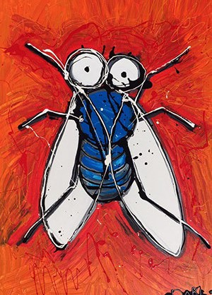

A Fly by Tanya Darl – sold through Access Arts

2018 saw Access Arts brokering sales opportunities. It’s not just the money, it’s also

the self-esteem, confidence and pride this brings to our artists. Artists sold artworks at exhibition opportunities we brokered around Brisbane and Ipswich in addition to exhibitions we organised. 15 artists sold at KPMG, takings were $3,555; 4 artists sold 7 artworks at Brisbane Square Library, takings were $1,060: “Access Arts has been the most positive and supportive experience for me and continues to be very important in my life.”

2018 also saw Access Arts facilitating one-off sales and commissions:

- In July the Director of Social Scaffolding bought two paintings by artist Tanya Darl to gift to community organisations he had worked with, for them to display her artworks in their offices. These sales totalled $500.
- In December he purchased another painting by Tanya Darl for $250 for a Christmas gift.
- In December the Manager of Real Estate Development at Enterprise Real Estate asked to purchase an artwork by Lisa Blake he had seen on display at KPMG. But, as this was already, sold Access Arts arranged for Lisa to create a commissioned artwork for Karl. Sale price was $340.
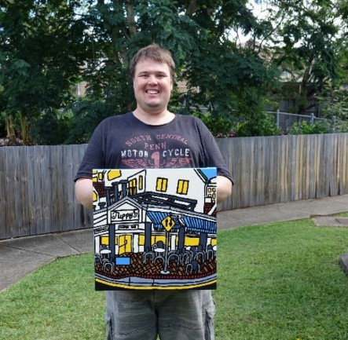
Peter Hughes with one of his artworks that were sold through the Access Arts office
- 2 Peter Hughes’ artworks sold as a result of his exhibition in the Access Arts office space. Together with 3 other artworks sold through the office, takings totalled
$967.50.
- Exceptionally, BrisStyle allowed Access Arts artists to exhibit in their December ‘A Handmade Christmas Market’ at State Library of Queensland - exceptionally because this opportunity traditionally is only open to BrisStyle members. In this integrated environment our artists’ work stood up against the BrisStyle artisans’ artwork. 16 artists sold artwork, takings totalled $1,219 making their Christmas come early!
- Then, just before Christmas the Office of the Public Guardian Queensland approached Access Arts to purchase a digital artwork which became their e- Christmas card. Their acknowledgement of artist Lisa Blake and Access Arts by name in their Christmas email enabled our names to reach out to a new market.

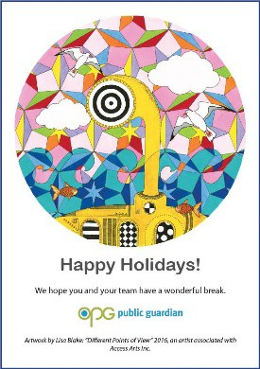

Lisa Blake's artwork which featured on the e- Christmas card of the Office of the Public Guardian

The Changing Environment

In 2018 we prepared for the most dramatic change in the funding context that Access Arts has had to address during its 35-year history. With the onset of the NDIS our block funding from Queensland Government Department of Communities, Child Safety and Disability Services reduced during the second part of the year, and will cease completely by 30 June 2019. To help mitigate this, Access Arts successfully secured from Arts Queensland additional future funding of $150,00 per annum for the years 2019 and 2020.

We registered as an NDIS Provider; analysed, interrogated and changed our business model and systems to adapt to operating under the NDIS. We developed work plans, and organised intensive training for our office staff, artsworkers, participants and their advocates.

With advice and support offered pro bono from CPL and Arafmi, Access Arts ran an intensive program of individual mentorships on a one-on-one basis to assist members to pre-plan for their Plan Meeting.

Meantime, during the year Australian Government Department of Prime Minister and Cabinet renewed our Deed for 2018-2019 for Access Arts to continue our arts workshop program with First Australians, a workstrand Federal Government has continually funded since the 1990s.

A National Network
Access Arts is Queensland’s peak body for arts and disability. We advocate not only for people with physical or mental disability but also for people who experience disadvantage to take part and excel in the arts. We are part of a national network of State and Territory peak bodies across Australia. The National CEO
Leadership Group comprises CEOs from the other peak bodies and is convened by the national peak body, Arts Access Australia. In 2018 we worked together on several joint national projects. We continued our intelligence-gathering on how the NDIS is affecting the sector nationally and our advocacy role to Australian Government in this regard. We supported the appointment of Diverse Werks to manage the national consultation on the National Arts and Disability Strategy and promoted their focus groups in our respective States/ Territories. We laid the groundwork to roll out Arts Access Victoria’s ARTfinder database nationally. Access Arts sowed seeds for the Leadership Group’s future involvement in our next national Undercover Artist Festival which we plan for 2020. The National CEO Leadership Group aims to meet twice a year.
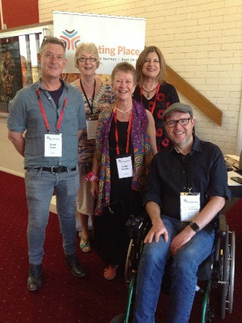
Pictured here with me in September at Alice Springs at the sector’s national conference ‘Meeting Place’ are leaders David Doyle, Executive Director of DADAA, West Australia; Jenine Mackay, CEO of Incite Arts, Alice Springs, Northern Territory; Meagan Shand, CEO Arts Access Australia and Martin Sawtell, Business Manager, Access2Arts, South Australia.

Pat Swell Chief Executive

TREASURER’S REPORT
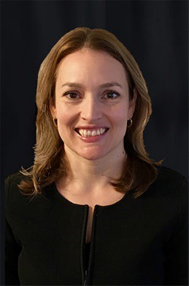
I am pleased to present the Audited Financial Reports for the Financial Year ending 31 December 2018.

Revenue for the 2018 year was $684,394 (2017: $779,546). In 2018, revenue included Queensland and Australian government grants totalling $585,584 (2017: $658,864). In 2017, Access Arts delivered the bi-annual Undercover Artist Festival with specific additional Arts Queensland funding. For the first year in 2018, the organisation received National Disability Insurance Scheme (NDIS) revenue of $19,658 (2017: $0) as workshop participants received their NDIS packages and chose to purchase services from Access Arts. Pleasingly workshop participant fees $28,163 (2017: $25,504) and donations $16,288 (2017:
$12,861) both increased in 2018 demonstrating sustained support for Access Arts programs.

The organisation made a loss for the year as shown the Statement of profit or loss and other comprehensive income of $16,210 (2017: profit $8,585). The loss reflects the challenges faced in supporting our workshop participants, arts workers and leadership team transition to the NDIS. The management committee recognised the need for additional training and other resources.

At the end of December 2018, the Balance Sheet shows a cash and cash equivalents total
of $296,841 (2018: $339,470). The net assets of the organisation were $257,368 (2017:
$287,182). The net assets include $90,594 (2017: $89,940) for the SAFE Fund and $21,581 (2017: $34,475) for the Access Arts Achievement Award held as restricted reserves. Retained surplus not restricted totalled $146,557 (2017: $162,767).

The organisation has spent 2018 exploring options for its future under the NDIS and believes the proposal submitted for vote at the March 2019 Special General Meeting will result in stability and financial certainty for the art workshop programs and awards and continuation of Access Arts’ mission and values. Should the resolution be unsuccessful, the Committee and leadership team will continue to pursue options to maintain high quality contribution and access to Queensland’s arts community for artists with disability and disadvantage.

Nicola Leahy Treasurer

A YEAR AT ACCESS ARTS

A busy year celebrating our artists’ skills, nurturing development and preparing for the NDIS

‘Access Arts is helping to change my life and has been a life-saver for me’

January

- The Governance Review of Access Arts by Board Matters reported: “Access Arts is an organisation that operates extremely well overall in both a governance and a management sense”.
- Human Services Quality Framework external audit of Access Arts by Global- Mark, passed with flying colours.
- First Aid Training – for our workforce.

March

- This Is Where I Belong - intensive weekend arts workshop where women of all abilities explored theatre, story-telling, dance, music and visual arts: “It made me bolder”.
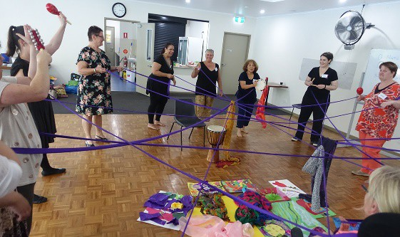

This is Where I Belong workshop participants

- Meaningful Mandala – State Library of Queensland commissioned Access Arts to create an interactive installation, a participatory visual arts project as part of their exhibition ‘Lifestyle: a Sunshine State of Mind’. Meaningful Mandala opened in March and continued at State Library until
October. “My favourite part [of Lifestyle] is the ‘Meaningful Mandala’ cut and paste craft activity. I could sit down and do with my two-year-old niece to create a small piece of what we enjoyed about living in Queensland that we could add to the exhibition.”
- Songs From Our Suburbs - Access Arts Singers’ first performance of the year to a packed audience at Upper Kedron Community Hall.
- Moreton Bay Region Art Awards – we supported visual artist Belinda Peel to enter. Her artwork was in the finalists’ exhibition, an annual acquisitive exhibition supported by Moreton Bay Regional Council.
- Chiaroscuro: Beauty in Contrast – organised by the Royal Queensland Art Society, we supported visual artists Belinda Peel, Lisa Blake and Tanya Darl to exhibit.
- Culture Counts – Melbourne-based global leaders in cultural measurement chose Access Arts out of all their clients nationally as a model organisation to film as a promotional tool for their website.

April

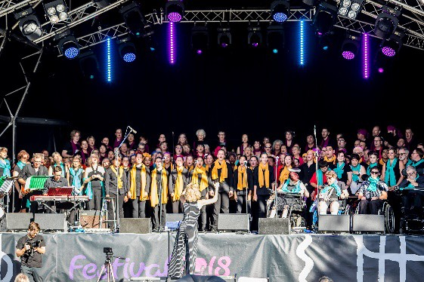
- Songs from our Suburbs - Access Arts Singers’ second performance, this time to 1,200 people on the South Bank Cultural Forecourt as part of Festival 2018 celebrations. Our lead artsworker said: “This project forced me to step up and believe in myself, having to conduct in front of a new group of singers as well as choral superstars. Thank you so much.”

- NDIS Training - delivered to our office staff and artsworkers with the support of CPL, exploring what the NDIS is and how it will affect our arts workshops and participants.
- $1,000 Safe Grant - awarded to musician Angus Macfarlane, who used it to have seven of his original electronic compositions professionally mixed, recorded and made into a CD to promote his music: “it finally closed a chapter of my life and opened my opportunities by progressing to a musical level that will be interesting to people, my band and myself”
- Brisbane: Landscapes, Landmarks and Personalities – artists Belinda Peel and Tanya Darl exhibited at Petrie Terrace Art Gallery, a collaboration with the Royal Queensland Art Society.
- Mentoring Magda – we brokered for Camera Wanderer Magda Labuda to be mentored by QAGOMA’s Head of Marketing and then supported Magda in the development of her marketing skills in preparation for her solo exhibition ‘BrisVegas at Night’ at Reverends Fine Coffee, Fortitude Valley, in November.
- Commonwealth Games – 49 Access Arts’ members and their families enjoyed various events, with complementary tickets given to us by KPMG.
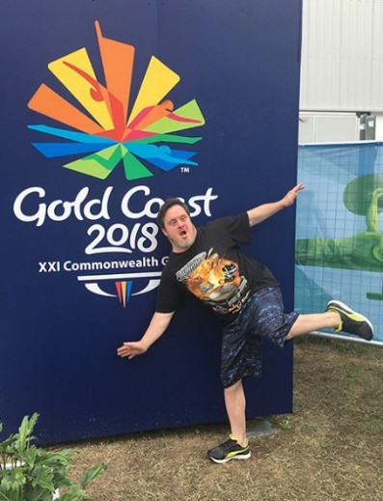
Camera Wanderer Matthew Lys at the 2018 Commonwealth Games
May

- NDIS Training - delivered to our members and their advocates, our artsworkers and office staff, with the support of CPL. We explored how members could register for the NDIS and pre-plan: “It was a lovely friendly informative session thanks”.

June

- Community Sharing Week – we opened our arts workshops to the public, and new members joined us as a result: “Access Arts invited us to join in the fun and I discovered I actually have rhythm!”
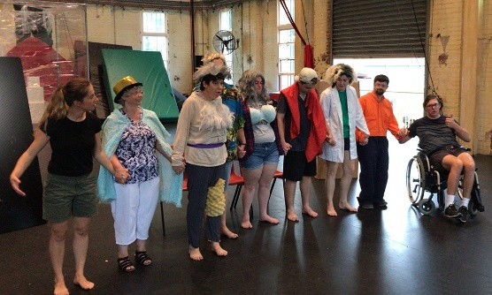

Taking a bow at Brisbane Powerhouse during Community Sharing Week

- Song-writing and Spoken Word on the Western Downs – public celebration by First Australians living in Dalby and St George following our arts workshop partnership with Sage Music and Goondir Health Services.
- Disability Awareness Training – the first of five sessions we delivered to Arts Queensland staff during the rest of the year: “It has opened my eyes to how difficult it can be for people with disability in the community”.
- Exhibition of artist Peter Hughes – was hung in Access Arts’ offices, remained until December, two of his artworks sold.

July

- Meaningful Mandala – as a winter school holiday program State Library of Queensland brought our interactive installation out onto their Knowledge Walk where young participants created 1,600 Mandalas, reaching a whole new audience for Access Arts.
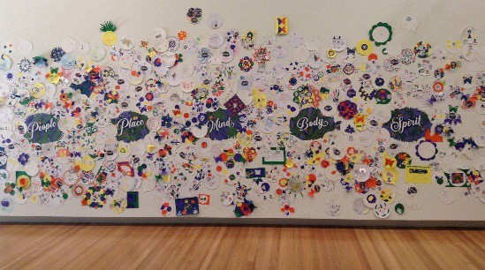

Meaningful Mandala

- Tonic Health Media – included a video of an Access Arts’ master class led by international choreographer Marc Brew in their ‘backbone’ content, which meant our video was played in doctors’ surgeries across 3,632 GP Practices nationally three times a week for the rest of the year.

August

- Tokyo – visual artists Tanya Darl and Belinda Peel exhibited their artworks at Japan’s Paralym Art World Cup 2018, having received the highest scores out of all applications from across Australia: “Thank you very much for your help with the Japanese entry...I admire your understanding of it! I don’t think I could have done it without you. :-)”
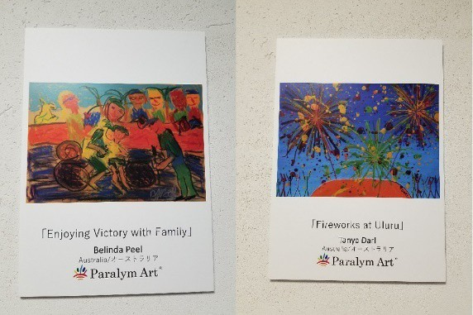

Artwork by Belinda Peel (left) and Tanya Darl exhibited at Japan's Paralym Art World Cup 2018

- Strathpine – we supported artists Belinda Peel, Lisa Blake and Tanya Darl to exhibit in Pine Rivers Art Gallery ‘Black Dog Blue Butterflies’ exhibition.
- Ipswich – in partnership with Arts Connect, all 10 of our BOA artists exhibited in their exhibition ‘Having Our Voices’ at Ipswich Community Gallery.

September

Places of the World and Imagination - our artists’ exhibition at Brisbane Square Library hung for 2 months. “Grateful for the professional development I gained from helping to curate and hang Brisbane Square Library exhibition” said visual artist Lisa Blake. Cr Steven Huang, Brisbane City Councillor for MacGregor Ward, enjoyed the artists’ tour led by Belinda Peel, Tanya Darl led a second tour a month later.
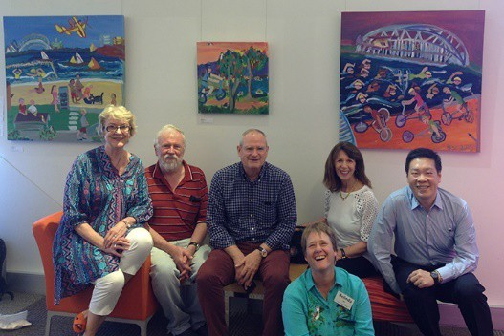

Belinda Peel (seated) with Cr Steven Huang (far right) and members of her tour at Brisbane Square Library

- Where Nature Meets Civilisation - our annual signature exhibition at KPMG’s prestigious offices in the CBD where our Theatre Ensemble and First Australian musician David Peacock (right below) performed at the private view. Opened by our Patron His Excellency The Honourably Paul de Jersey AC Governor of Queensland (centre below) and Ms Jennifer Howard MP, member for Ipswich, the exhibition hung for 3 months, enjoyed by 15,000 people.

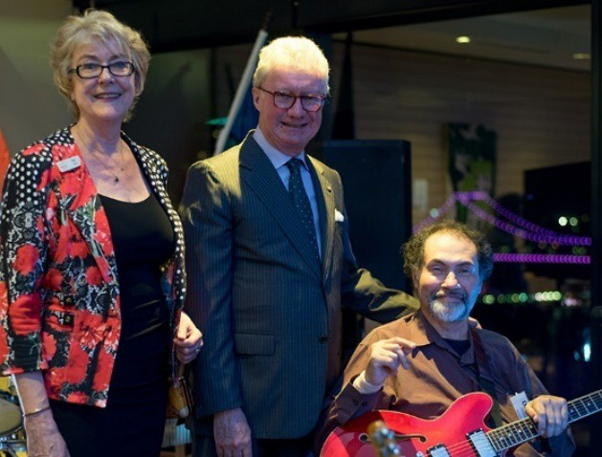

- New Beginnings – we supported 12 artists to exhibit in Art From the Margins’ Outsider Art exhibition.
- Alice Springs – representing Access Arts at ‘Meeting Place’, the annual national forum for the sector that our national peak body, Arts Access Australia, organises.

October

- Caring Fairly Carers Forum - marking Queensland Mental Health Week, Arafmi commissioned our Rhythm Circle to demonstrate their drumming skills at Brisbane Convention Centre during this Forum: “We got into a state of flow and freestyling, the audience got up and joined us!”

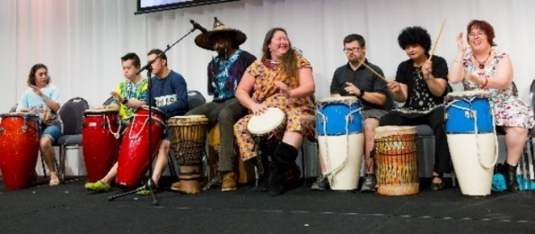

Rhythm Circle performing at Caring Fairly Carers
Forum

- Glow – all 10 of our BOA artists exhibited in Mental Illness Fellowship Queensland’s exhibition at King George Square, also marking Queensland Mental Health.
- Grant Writing Workshop - led by Arts Queensland for aspiring entrants to our Access Arts Achievement Award: “I am very happy with the impact it will have and help direct my decisions and options for my project”.

November

- National Arts and Disability Strategy – support for the Queensland consultations.

December
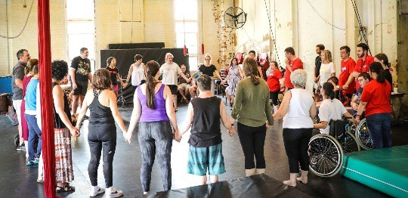
‘Leaps and Bound’s participants at Brisbane Powerhouse

- Rejoice With Us – Our Rhythm Circle provided musical accompaniment to the grand finalé of our circus and dance project ‘Leaps and Bounds’, and Access Arts Singers performed at Brisbane Powerhouse as we celebrated the end of 2018 together with Brisbane City Councillor for Central Ward, Vicki Howard.

$10,000 Access Arts Achievement Award
– our 2018 winner was Gold Coast visual artist Carol Taylor.
  - A Handmade Christmas Market - in the precinct of State Library of Queensland our visual artists collaborated with BrisStyle’s artisans, celebrating their handiwork by selling their arts and craft work in the run- up to Christmas.
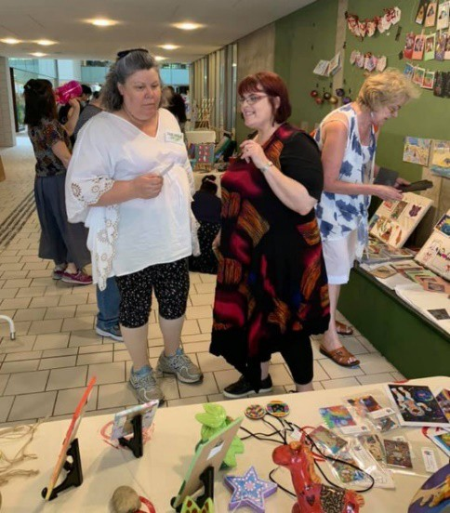
Access Arts artists at A Handmade Christmas Market, State Library of Queensland

  - Karul Projects – following an intensive three-week rehearsal period, this First Australian company newly returned to Queensland performed at the Judith Wright Centre of Contemporary Arts, a partnership with BlakDance Australia Ltd.

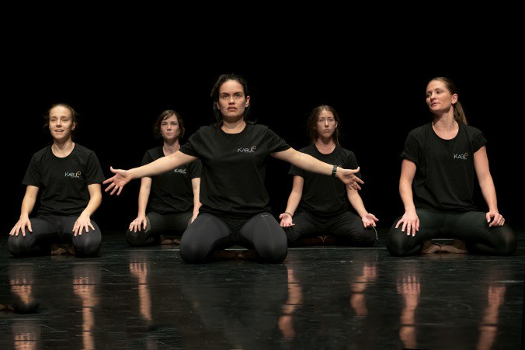

Karul Projects performing at the Judith Wright Centre of Contemporary Arts
- NDIS Training – for our members and their advocates, artsworkers and office staff. With the support of Connect Plan Management and Synapse we explored Plan Management and Support Co- ordination.
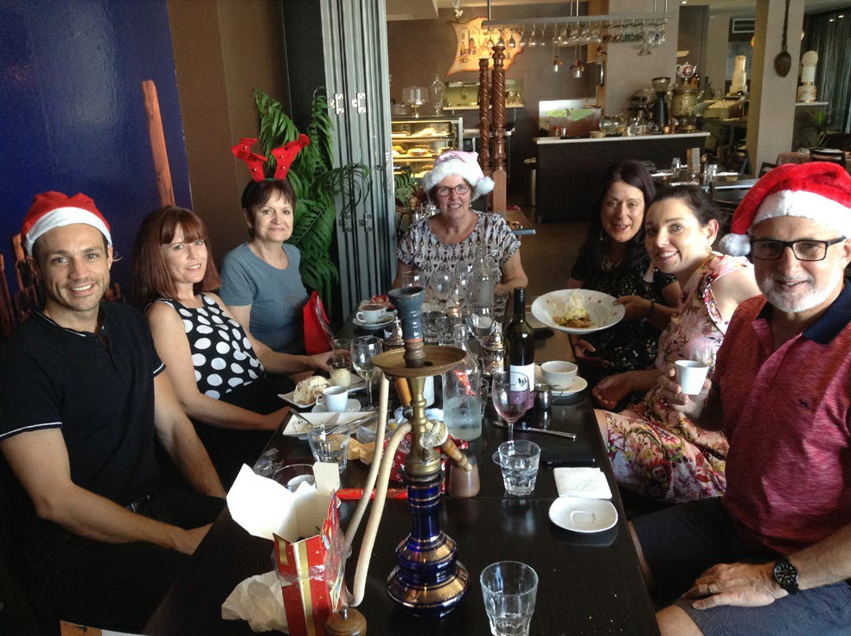

After a great year, Access Arts’ office staff relax over Christmas lunch. Left to right: Tim Brown, Jasmin Coleman, Mary Schneider, Lyn Hair, Angela Witcher, Carla Sanzone, Andy Stephanos

- OUR THANKS TO

Our Funders
  - State Government of Queensland:
    - Arts Queensland;
    - Department of Communities, Child Safety and Disability Services,
    - Department of Child Safety, Youth and Women
  - Australian Government:
    - Department of Prime Minister and Cabinet;
    - Department of Health
  - Australian Cultural Fund
  - Brisbane City Council: Central and The Gabba Wards

Our Partners
In 2018 we received in-kind donations estimated at $53,600 in value, from:

Arafmi
BrisStyle
Connect Plan Management
CPL - Choice Passion Life
Deaf Services Queensland
Holly Gibbons
InsideOutside Theatre
KPMG Queensland
Microsoft
NDS QAGOMA
Reclink
State Library of Queensland
Andrew Stephanos Synapse
Tonic Health Media

Our Donors
In 2018 our private sector donations increased by 31% on 2017. KPMG Queensland named Access Arts as its Key Charitable Partner. We experimented with two new fundraising platforms - Everyday Hero and the Australian Cultural Fund – in addition to our ‘Give Now’ platform and direct debit/ cash through which
we received donations in previous years.

Individual donors:

Lisa Bartley
Harmony Blyth
Michael Bor
Thomas Bradley
Timothy Brown
Weston Bruner
Eloisa Bruner
Will Bruner
Vanessa Byrnes
Andrea Carroll
Sheila Clark
Liz Crawford
Brad Daniels
Agnes and Joel De La Cruz
Paul Finn
Mike Gilmour
Yvonne Henry
Maria Heves
Jill Holloway
Karen Jones
Linda & Phillip Kowalski
Wendy Lavelle
Nicola Leahy
Jessica Leong
Trent Little
Lu
Patrice McKay
Chanelle McKenna
Desmond B Misso
Adrian Morgan
Cindy Mossop
Mr Mulvey
Sam Nicolosi
Chris O'Bryan
Magdalena Pieciun
Donna Power
Stephen Rowe
Carla Sanzone
Pooja Sawrikar
Mary Schneider
Pamela Siebrecht
Russell Solomon
Pat Swell
David Tepper
Mandy Thomas
Angela Tillmanns
Tara Turner
Peter Vance
Dave Vatz
Sarah Voiselle
Mary Waldie
Lauren Watson
Adam Whitehead
Callum Young

In 2018 we welcomed Lyn Hair as much-valued volunteer working one day a week. We were sad to lose our Finance Officer Andy Stephanos who worked tirelessly to ensure our finances were sound, and later Angela Witcher our Access Services Co-ordinator who developed our Creative Ageing, Disability Awareness Training and Access Appraisal programs. Angela continues her work with us on a project basis. We welcomed Genevieve Dubler as Book-keeper and Julie Woodward on a short- term contract to assist with NDIS transition. In September we restructured promoting Tim Brown to Arts Manager.
Organisational donors:
ADFAS (Brisbane River) Inc
Brisbane City Council – Paddington Ward
Derwent Executive
KPMG Queensland
MinterEllison
Sandgate Anglican Church
Our Patron
His Excellency the Honourable Paul de Jersey AC, Governor of Queensland

Our Management Committee
President - The Honourable Justice Thomas Bradley
Treasurer – Nicola Leahy, business analyst: advised on our business modelling
Secretary – Liz Crawford, HR expert: supported the office team through cultural and organisational change
Ordinary members
- Weston Bruner, fundraising expert - in 2018 donations increased by 31% on 2017
- Lorelei Baum, communications expert – advised and supported our communications
- Patrice McKay, business expert - advised on financial and business matters
- Adrian Morgan, expert in aged care - joined the management committee in March 2018 bringing specialist insights at the time of the Government Inquiry into Aged Care
- Sam Nicolosi, business and training expert - advised on our ICT changes and upgrades
- Angela Tillmanns, NDIS expert – supported us in the transition of our systems to the NDIS.

Our Staff
Office staff in post at 31 December
2018 were:
- Tim Brown - Arts Manager
- Jasmin Coleman – Visual Arts
Coordinator
- Genevieve Dubler – Book-keeper
- Rachel Gaffney-Dawson – Visual
Arts Coordinator
- Narelle Hill – Business Manager
- Carla Sanzone – Administrator
- Mary Schneider – Administrator
- Pat Swell – Chief Executive

Our Arts Workers bring outstanding talent to Access Arts programs. The artists who ran our regular weekly workshop programs during 2018 were:

Brooke Austen
Sophie Banister
Genevieve Butler
Man Cheung
Linda Clark
Francesca Co-Beng
Leah Cotterell
Amy Davidson
Ruby Donohoe
Sarah Dunstan
Eleonora Ginardi
Alice Gittins
Cat Holland
Katie Martin
Tich Mashawa
Marty O'Hare
Anthea Patrick
Velvet Pesu
Sam Smith
Walter Stahl

Contact details

Access Arts
E: info@accessarts.org.au
W: http://www.accessarts.org.au

