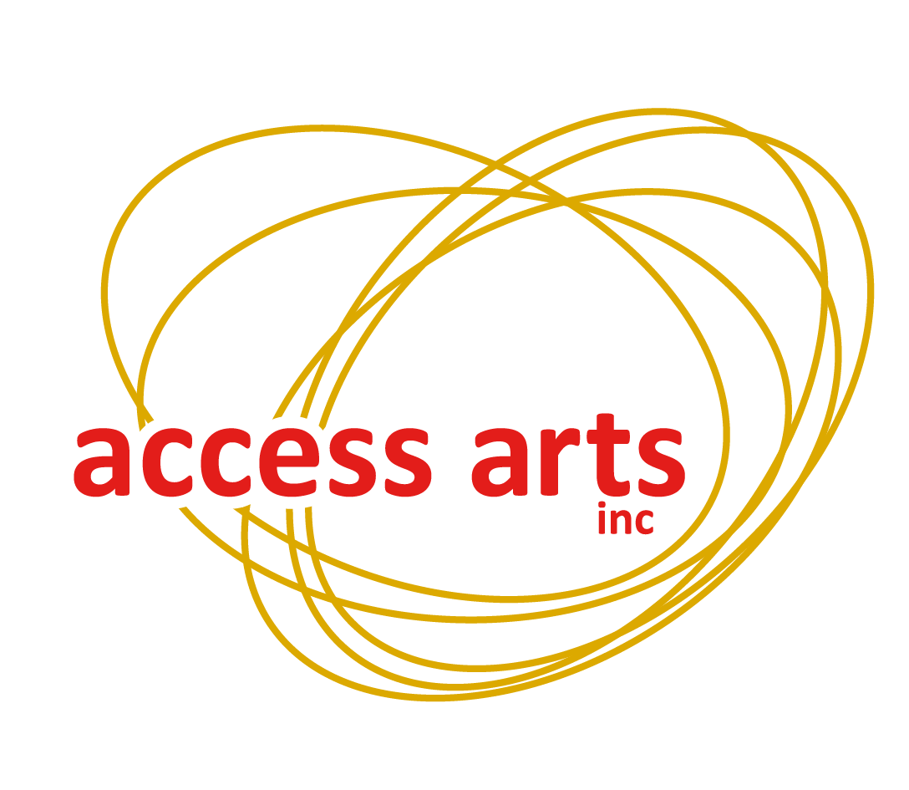

**Access Arts Inc**

1F/24 Macquarie Street  
Teneriffe QLD 4005

**Phone:** (07) 3254 9585  
**Local:** 1300 663 651  
**Email:** info@accessarts.org.au

**www.accessarts.org.au**ABN 82 066 160 761  
 **Patron:** His Excellency the Honourable Paul de Jersey AC  
Governor of Queensland

**Media Policy**

*All Access Arts policies relate to all Staff as well as Members.*

Access Arts Inc. defines a Member as any person who has filled out a membership form and paid the appropriate fee to join the organisation.

Staff are defined as persons engaged in Office, workshop/project or program, Volunteer or Student placement work with Access Arts Inc.

**Definition:**

Access Arts defines media as methods of communication that are distributed through technologies such as newspapers, newsletters, magazines, computer, radio, television; and other written and audio-visual materials.

**Purpose:**

To improve the profile of Access Arts, its projects and programs by ensuring timely, respectful and relevant communication with the media.

**Aims:**

* To reinforce positive public images of people experiencing disability or disadvantage at all times.
* To use each opportunity, when involved with the media, to educate the broader community, on using appropriate language to reinforce positive imagery.
* To increase/guarantee funding by being recognised amongst governance, partners and sponsors as a stable organisation that gives a good return on their investment.
* To increase membership (especially regionally) and encourage the involvement of existing members in programs that they see as exciting and/or beneficial to the development of their artistic aspirations (career or personal).
* To raise the profile of Access Arts within the Arts community as an organisation whose members produce work that is competitive within the Arts community.
* To raise general community awareness of Access Arts and what it does.

(See Marketing Objectives in the Marketing Plan for more examples.)

**Policy:**

General Points:

* Marketing material must be accessible to people with disabilities.
* The Chief Executive Officer should be advised by Members or Staff, prior to any contact with the media. A senior Access Arts Inc. Staff person should be in attendance at the media interview.
* Funding must be allocated for Media and Marketing for all Access Arts Inc. projects.
* The Assistant Director is to oversee all marketing activities.
* The coordinating Staff member for each project must be responsible for its Media and Marketing.
* When working in partnership with other organisations, a letter of agreement outlining the responsibility for Media and Marketing must be signed by all parties.
* Marketing must be a standing agenda item for staff meetings so that planning can occur for marketing of upcoming events.
* Access Arts Inc. must ensure that all stationery maintains a consistent design for branding purposes.

**Dealing with the Media:**

When dealing with the media the following points need to be stressed:

* Our Members are people first – do not focus on the disability.
* Do not use language which demeans or marginalises a person’s abilities, experiences or talents.
* Access Arts Members who are included in photographs should be referred to as either “Access Arts members”, “Access Arts participants”, or “community participants on an Access Arts project”.

**NB: Members must never be referred to by their disability or by their institution.**

* Always prepare a press release in advance when contacting media and give the media another copy of the press release at the point of interview.
* Follow up any interview with a journalist, by offering assistance to ensure that the article is written in the most positive way.

**Stakeholders:**

Stakeholders have been defined in the *Access Arts Media and Marketing Plan 2006* as follows:

1. Governance
   * Funding bodies (Arts Queensland, Disability Services Queensland)
   * Patron (Governor)
   * Management Committee
2. Partners and sponsors
3. Members and Public.
   * Current Members of Access Arts
   * Potential Members including people with disabilities and carers
   * Disadvantaged people (with an emphasis on disadvantaged Indigenous communities)
   * Arts communities (various levels)
   * General community (and especially regional communities)
4. Staff and Volunteers

Inevitably, some of the groups require different communication approaches ranging from personal face-to-face communication (with governance or partners) through newsletters (for Members) to media publicity (for wider audiences). However, the most important profile-raising opportunity across all stakeholder groups is clearly through using the media to best advantage.

**Media Procedure**

**Positive Language:**

The important objective is to refer to the person first, then, if necessary, to his/her disability.

* A person with a hearing impairment – **not** deaf or dumb.
* A person with a visual impairment – **not** blind.
* A person with intellectual disabilities or a person with learning difficulties – **not** retarded or intellectually challenged.
* A person experiencing mental illness or a person with a psychiatric disability – **not** mad or unbalanced or psychotic, neurotic, depressed, etc.
* A person with a physical disability – **not** physically handicapped or crippled or physically challenged.

**Hints for Working with the Media:**

1. **Use the regional angle whenever possible –** 
   * For example when there is a major achievement by somebody from a regional area, it is beneficial to personalise the media release. This can be achieved by organising a photographic opportunity or by changing the language of the media release depending on the area that is being targeted.
   * As an example, if work from three of your artists who come from country areas and one from Brisbane were to be selected as part of an international touring exhibition, the same basic media release would be targeted at: The Courier-Mail, Sunday Mail, Australian arts sections etc. This media release would feature a comprehensive angle such as “The work of four Queensland artists . . .”
   * A separate version of the same release targeted at the Courier-Mail’s country edition should be used saying: “Three country Queensland artists and one from Brisbane…”
   * A separate release for the Westside News (or whatever suburban paper is relevant saying: “A Kenmore man and three other Queenslanders . . . .”
   * The same procedure can be used for other forms of media such as the radio etc.
2. **Look for the human angle –** Stories of success in the face of adversity are always good publicity and provide the sort of “hook” or news value that enables your stories to stand out from other success stories.
3. **Always focus on today’s story –** When contacting the media, never question the publicity or lack of it for a previous event. Always concentrate only on the positives of what you’re currently trying to promote and stick to the subject. Never digress and never discuss anything controversial unless you want to see a mangled version of your comments on the front page.*(For further sample media releases and tips on working with the media, staff are advised to look under the Access Arts Inc. ‘S’ drive under the ‘Media Guidelines and Tools’ folder.)*

**Accessibility of Media:**

Being an organisation that works primarily with people experiencing disabilities, it is important to ensure that all Access Arts Inc. media is accessible to all. Simple factors such as considering the use of pictures as a method of conveying a message along with text, and not using PDF files assist in making media accessible to people with a visual impairment.

It is therefore necessary that all Staff at Access Arts Inc. take the time to consider how media is distributed and whether it is as accessible as possible. This in many cases may mean using multiple methods of communication to get information across to all Members or the targeted audience. An example of this is with the monthly newsletter. This form of media can be sent out by mail for some, and then easily emailed to those with a visual impairment. Text can also be accompanied by pictures, both conveying the same meaning, in order to make the message easily understood by a wider range of audiences.

If you would like anymore information on this topic go to “[Getting the Message](http://www.bca.org.au/Getting_the_Message.htm#_Toc140468717)”, or read ‘[Web Content Accessibility Guidelines 1.0](http://www.w3.org/TR/WAI-WEBCONTENT/)’ from W3.

**Culturally Sensitive Media:**

It is equally important that all Access Arts Inc. media is portrayed in a culturally sensitive manner. Barriers to accessibility such as language, difference in cultural values, customs and understanding must be addressed when releasing or distributing media.

Staff at Access Arts Inc. must ensure these issues are addressed when targeting different cultural audiences. It is especially important to consider cultural aspects when working with people experiencing disadvantage so as not to further disadvantage them through the use of inappropriate, insensitive or inaccessible media.

**In order to ensure that media is accessible and sensitive to people from different cultures it may be necessary to:**

* conduct staff training in cultural awareness
* use translators or other interpreting aids
* simplify language or use meaningful pictures (for those who do not know English well)
* consult with the relevant cultural communities before sending out media
* consult with organisations that specialise in working with different cultures.

***Complies with Queensland Human Services Quality Standards (HSQS): 1, 2, 3, 4  
Update Responsibility: Chief Executive Officer  
Date of last update: 09/08/2013***