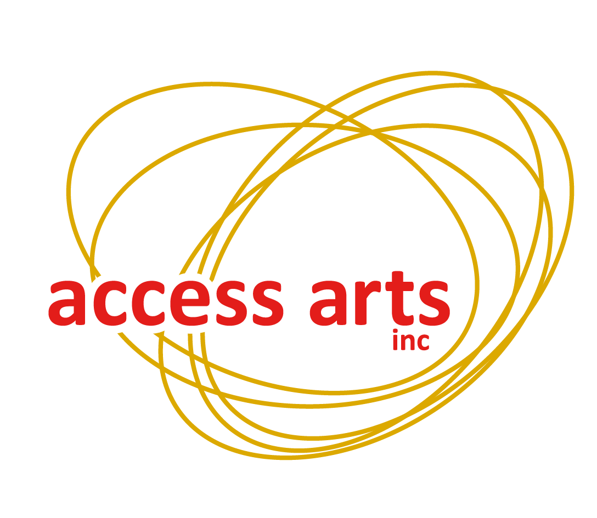

**Access Arts Inc**

1F/24 Macquarie Street  
Teneriffe QLD 4005

**Phone:** (07) 3254 9585  
**Local:** 1300 663 651  
**Email:** info@accessarts.org.au

**www.accessarts.org.au**ABN 82 066 160 761  
 **Patron:** His Excellency the Honourable Paul de Jersey AC  
Governor of Queensland

**Partnership Policy**

*All Access Arts policies relate to all Staff as well as Members.*

Access Arts Inc. defines a Member as any person who has filled out a membership form and paid the appropriate fee to join the organisation.

Staff are defined as persons engaged in Office, workshop/project or program, Volunteer or Student placement work with Access Arts Inc.

**Definition:**

Partnership: A joint venture between two or more parties in order to achieve an agreed outcome.

**Purpose:**

To ensure that all parties are represented fairly.

**Aims:**

* to establish clear guidelines for the reciprocal support provided to both parties
* to encourage a sustainable and respectful partnership between the two parties.

**Policy:**

All parties must complete a Partnership Agreement prior to the commencement of any project.

The Partnership Agreement will include:

* Names of all parties
* Project details, including commencement and completion dates
* A formal acknowledgement of mutual respect of each other’s policies and goals
* Detail of funding by all parties (including in-kind support)
* Details of all responsibilities of both parties
* Formally acknowledge copyright of all products of all parties
* A clause stating that all parties comply with Access Arts Media Policy
* A clause stating that all information sent out must include logos of all parties.
* A dispute and termination clause

***Complies with Queensland Human Services Quality Standards (HSQS): 1  
Update Responsibility: Chief Executive Officer  
Date of last update: 09/08/2013***