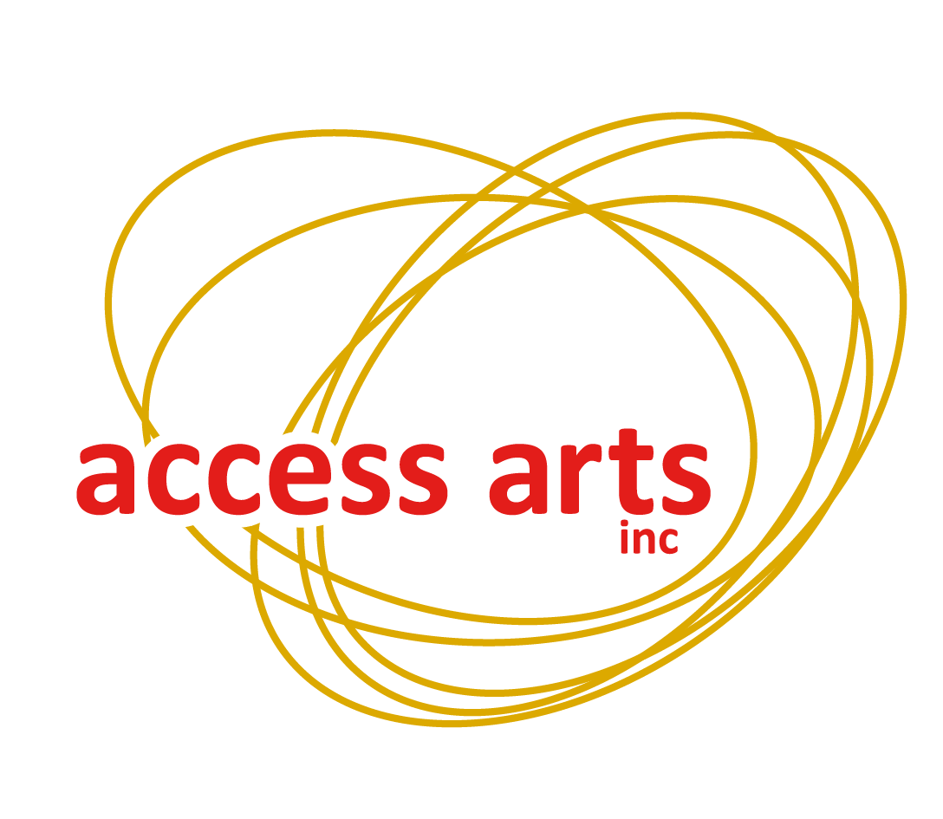
Access Arts Inc
1F/24 Macquarie Street
Teneriffe QLD 4005
Phone: (07) 3254 9585
Local: 1300 663 651
Email: info@accessarts.org.au
www.accessarts.org.au
ABN 82 066 160 761
Patron: His Excellency the Honourable Paul de Jersey AC
Governor of Queensland

Disability Access Policy

All Access Arts policies relate to all Staff and Members.

Access Arts Inc. defines a Member as any person who has filled out a membership form to join the organisation.

Staff are defined as persons engaged in Office, workshop/project or program, Volunteer or Student placement work with Access Arts Inc.

Purpose:
Access Arts is committed to providing their staff and members with equitable access to the arts, employment and appropriate education and training opportunities.

Aims:
- To ensure that all Access Arts projects are accessible to all members, in line with the Disability Discrimination Act (1992) through the Human Rights and Equal Opportunity Commission (HREOC).
- To ensure that all organisations that Access Arts partners with are accessible to all Access Arts members.

General Access:
Access Arts is committed to providing their members with equitable access to the arts. This includes ensuring the office space, all workshops, events, and projects are completely accessible.

Access Arts provides newsletters, mail-outs, policies, and all other required information in alternate formats, on request, including Braille, large print, audio and html or word.doc email. Access Arts' website complies with w3c web access standards of using html based web design to enable accessibility for those who use screen reading software. Access Arts advocates for the accessibility of websites and electronic forms of funding bodies through both Queensland and Commonwealth Government and other funding sources. Access Arts also encourages other arts organisations to comply with these web access standards.

Staff Recruitment and Development
Access Arts recognises the considerable contribution and skills that employees experiencing disability brings to the workplace. Access Arts encourages people experiencing disability or disadvantage to apply for all advertised positions. The organisation proactively recruits and employs skilled administrators, arts workers, cultural workers and volunteers experiencing disability or disadvantage. Developing local, regional, national and international reciprocal partnerships and the provision of appropriate training and skill development opportunities are an essential element of our philosophy for staff, volunteers and members.

Access Arts is also strongly committed to supporting Indigenous members. We endorse the community's desire for self determination and our staff are participating in gaining knowledge of Indigenous protocols. This provides a base for the Indigenous community members to build more collaborative networks, strengthen cultural activity and gain access to training and employment through programs of creative development.

The accessibility of the Access Arts workplace is a significant factor in making it conducive for staff with disabilities. The flexibility exists for staff to support one another when unexpected issues arise. These could include illness, family commitments or having time out to deal with the impact of each individual's particular disabilities. All Access Arts office and workshop staff and volunteers attend compulsory Disability Awareness Training as part of the induction process.

Access Arts adheres to the Workplace Health and Safety Act 2011 and supports employees experiencing disability to receive the appropriate workplace modifications in order to ensure a safe and healthy workplace for all staff.

Disability access and equity considerations are addressed in all of Access Arts' policies, procedures and organisational operations.

Feedback From Members and the Community
Access Arts has a commitment to its members, staff and community members experiencing disability to ensure that the quality of services is of a high standard. Access Arts invites feedback from members and staff regarding the accessibility of its programs, workshops, media material and venues.

As part of this commitment to continuous improvement, Access Arts strives to hold regular focus groups of members throughout the year in order to receive feedback on our services and programs. These focus groups also help Access Arts to understand the needs, interests and aspirations of our members in the arts. Members of the community participating in or witnessing our programs for the first time are invited to provide Access Arts with written or verbal feedback on the accessibility of our programs.

Staff members receive regular supervisions sessions and are encouraged to share any access or equity issues relating to their employment with their supervisor and/or the Chief Executive Officer.

Complies with Queensland Human Services Quality Standards (HSQS): 1, 2, 3, 4, 5, 6
Update Responsibility: Chief Executive Officer
Date of last update: 08/08/2013

